SAUSAGE AND BEAN CASSEROLE  COOK TIME: 40 mins  SOURCE: Unknown  #sausage #Mediterranean #one-pot | 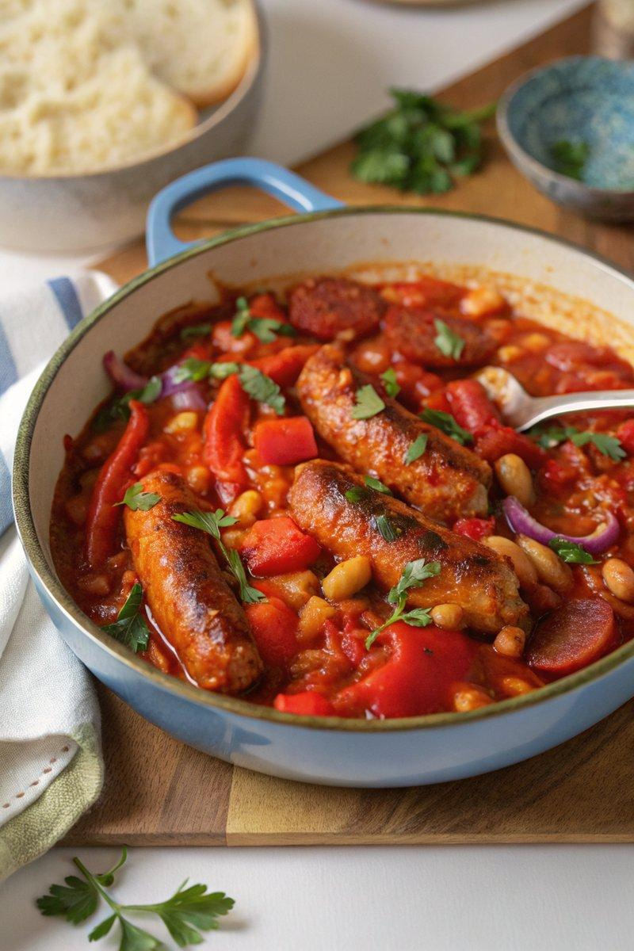

INGREDIENTS  - {'group': 'Main', 'item': '2 tbsp sunflower oil'}  - {'group': 'Main', 'item': '20 chipolata sausages'}  - {'group': 'Main', 'item': '1 large red onion, roughly chopped'}  - {'group': 'Main', 'item': '2 red bell peppers, deseeded and roughly chopped'}  - {'group': 'Main', 'item': '20 mini chorizo, halved'}  - {'group': 'Seasoning', 'item': '3 garlic cloves, minced'}  - {'group': 'Seasoning', 'item': '2 tsp paprika'}  - {'group': 'Seasoning', 'item': '1 tsp dried thyme'}  - {'group': 'Sauce', 'item': '120ml red wine'}  - {'group': 'Sauce', 'item': '2 chicken stock cubes, crumbled'}  - {'group': 'Sauce', 'item': '3 x 400g cans chopped tomatoes'}  - {'group': 'Main', 'item': '1 x 400g can haricot beans, drained and rinsed'}  - {'group': 'Main', 'item': '1 x 400g can cannellini beans, drained and rinsed'} | PREP  Roughly chop the red onion and red bell peppers. Halve the mini chorizo. Mince the garlic cloves.  COOK  Heat the sunflower oil in a large non-stick frying pan over medium-high heat. Brown the chipolata sausages for about 6-8 minutes, turning to ensure even browning. Add the chopped onion and cook for 3 minutes until softened. Stir in the red peppers and chorizo, ensuring the chorizo makes contact with the pan, and cook for another 3 minutes. Add the minced garlic, paprika, and thyme, stirring for 1 minute. Pour in the red wine and let it reduce for 2-3 minutes, scraping the pan to incorporate any browned bits. Crumble in the chicken stock cubes, add the chopped tomatoes, and bring to a gentle boil. Reduce the heat and simmer for 15 minutes, stirring occasionally. Add the drained haricot and cannellini beans, stir, and cook for an additional 5 minutes until heated through.  PLATING  Serve the casserole hot with a side of mashed potato.

NOTES:
This dish can be made ahead and stored in the refrigerator for up to 2 days. Reheat thoroughly before serving. For a slow cooker version, transfer the mixture to a slow cooker after adding the tomatoes and cook on low for 6 hours or high for 3 hours, adding the beans in the last 30 minutes.

