BUBBLE AND SQUEAK WITH CRISPY BACON  COOK TIME: 15 mins  SOURCE: Unknown  #vegetable #British #pan-fry | 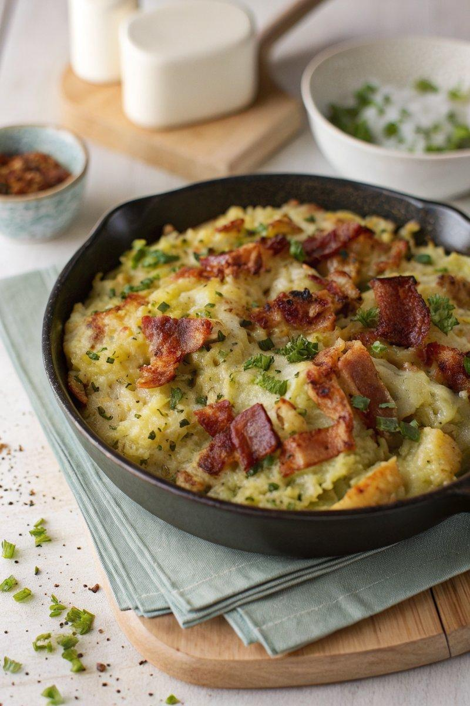

INGREDIENTS  - {'group': 'Main', 'item': '200g leftover cooked cabbage, chopped'}  - {'group': 'Main', 'item': '700g leftover mashed potato'}  - {'group': 'Seasoning', 'item': '4 tsp salt'}  - {'group': 'Seasoning', 'item': '1/4 tsp ground black pepper'}  - {'group': 'Main', 'item': '2 tbsp butter'}  - {'group': 'Main', 'item': '2 tbsp sunflower oil'}  - {'group': 'Garnish', 'item': '6 rashers crispy bacon, chopped'}  - {'group': 'Garnish', 'item': 'Chopped flat-leaf parsley'}  - {'group': 'For Serving', 'item': 'Poached or fried eggs'}  - {'group': 'For Serving', 'item': 'Brown sauce'} | PREP  Chop the leftover cooked cabbage and combine it with the mashed potatoes in a bowl. Season with salt and pepper, mixing well.  COOK  Preheat the grill. Heat 1 tbsp of butter and 1 tbsp of sunflower oil in a large frying pan over medium-high heat until the butter melts and bubbles. Add the cabbage and potato mixture, pressing it down to cover the pan's base. Fry for 5-7 minutes until the edges brown. Melt the remaining butter and mix with the remaining oil, then brush over the top. Place under the grill for 4-5 minutes until golden brown.  PLATING  Remove from the grill and sprinkle with chopped parsley. Serve hot, topped with crispy bacon and poached or fried eggs. Offer brown sauce on the side.

NOTES:
For a vegetarian version, omit the bacon or use vegetarian bacon.

