STICKY TOFFEE PUDDING WITH TOFFEE SAUCE  COOK TIME: 35 mins  SOURCE: Unknown  #dessert #British #bake | 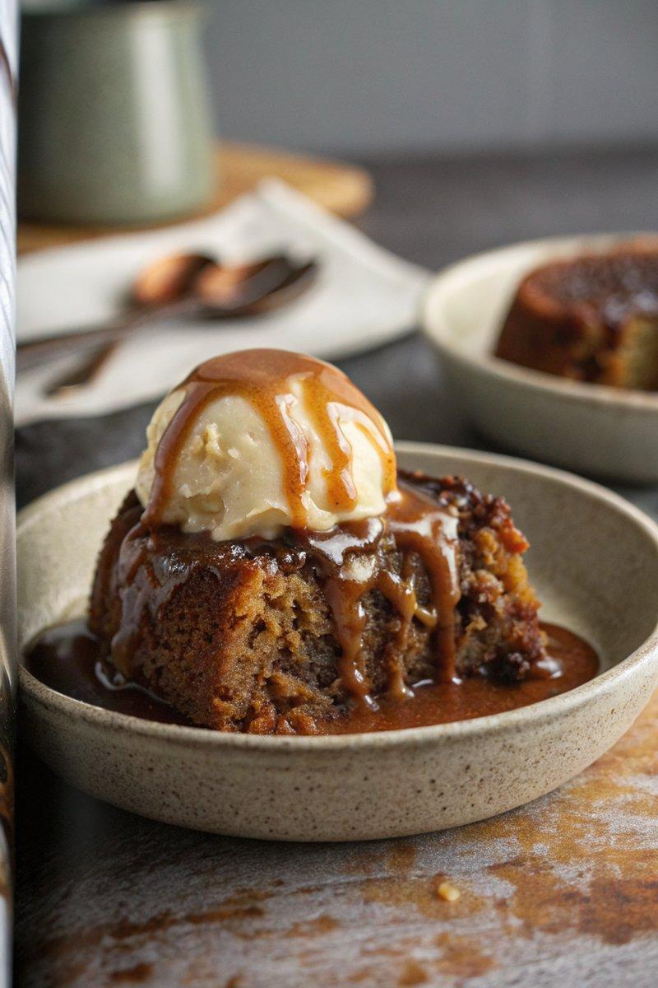

INGREDIENTS  - {'group': 'Main', 'item': '150g Medjool dates, pitted and finely chopped'}  - {'group': 'Main', 'item': '150ml boiling water'}  - {'group': 'Main', 'item': '90g unsalted butter, softened'}  - {'group': 'Main', 'item': '120g light brown sugar'}  - {'group': 'Main', 'item': '2 eggs'}  - {'group': 'Main', 'item': '2 tsp vanilla extract'}  - {'group': 'Main', 'item': '2 tbsp black treacle'}  - {'group': 'Main', 'item': '190g plain flour'}  - {'group': 'Main', 'item': '1½ tsp baking powder'}  - {'group': 'Main', 'item': '½ tsp bicarbonate of soda'}  - {'group': 'Main', 'item': 'a pinch of salt'}  - {'group': 'Main', 'item': '120ml milk'}  - {'group': 'Sauce', 'item': '175g light muscovado sugar'}  - {'group': 'Sauce', 'item': '60g unsalted butter, chopped'}  - {'group': 'Sauce', 'item': '240ml double cream'}  - {'group': 'Sauce', 'item': '1 tbsp black treacle'}  - {'group': 'For Serving', 'item': 'vanilla ice cream'} | PREP  Preheat the oven to 170°C (340°F (171°C)). Lightly grease a 28 x 18x4cm (7x2-inch (5cm (2-inch))) baking dish. Soak the chopped dates in boiling water for 10 minutes, then mash with a fork.  COOK  In a large bowl, cream together the softened butter and light brown sugar. Beat in the eggs one at a time, then mix in the vanilla extract and black treacle. Gradually add half the flour, baking powder, bicarbonate of soda, salt, and half the milk, stirring gently. Incorporate the remaining flour and milk until just combined. Fold in the mashed dates with their soaking liquid. Pour the batter into the prepared dish and bake for 25-35 minutes until the top is firm.  PLATING  While the pudding bakes, prepare the toffee sauce. In a saucepan, combine muscovado sugar, butter, and half the cream. Bring to a boil over medium heat, stirring until the sugar dissolves. Stir in the black treacle and let it bubble for 2-3 minutes until it turns light brown. Remove from heat and stir in the remaining cream. Pour half of the sauce over the baked sponge. Serve warm with the remaining sauce and vanilla ice cream.

NOTES:
For a salted version, add ½ tsp sea salt to the toffee sauce. The dessert can be made ahead and stored in the fridge for up to 2 days. Reheat portions in the microwave and the sauce on the stovetop until hot.

