CHOCOLATE ORANGE BREAD AND BUTTER PUDDING  COOK TIME: 25-30 mins  SOURCE: Unknown  #chocolate #British #baked | 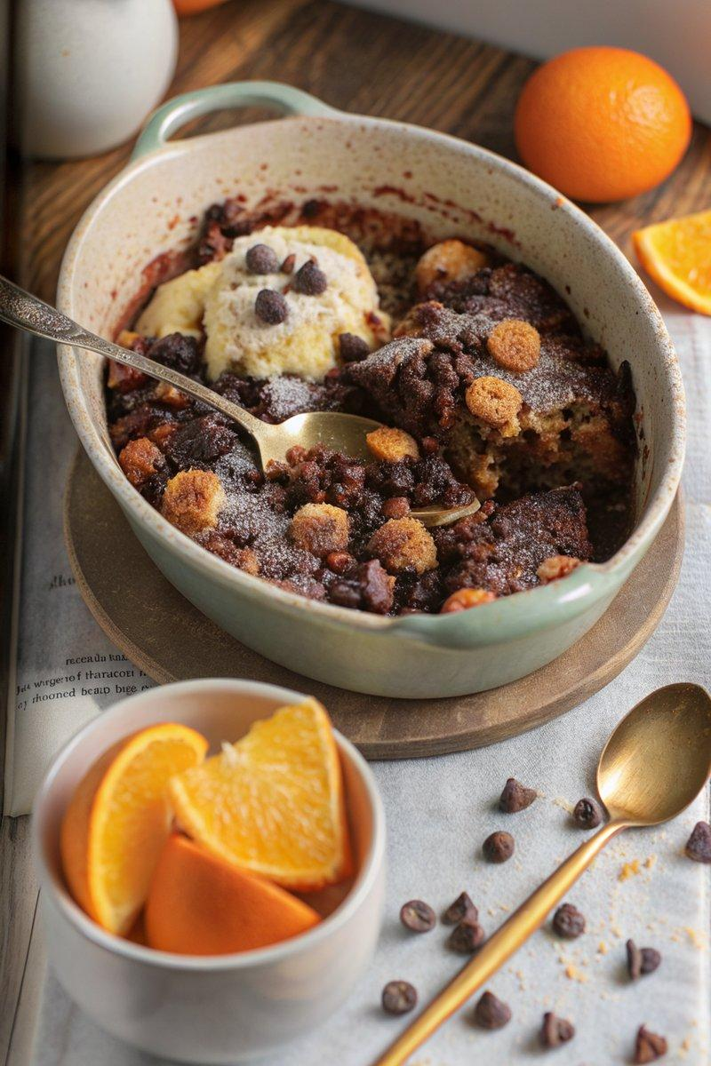

INGREDIENTS  - {'group': 'Main', 'item': '300g white bloomer-style bread'}  - {'group': 'Main', 'item': '3 tbsp unsalted butter'}  - {'group': 'Main', 'item': '100g candied peel chunks'}  - {'group': 'Main', 'item': '100g sultanas'}  - {'group': 'Custard', 'item': '240ml milk'}  - {'group': 'Custard', 'item': '300ml double cream'}  - {'group': 'Custard', 'item': '1 tsp vanilla extract'}  - {'group': 'Custard', 'item': '4 egg yolks'}  - {'group': 'Custard', 'item': '100g light brown sugar'}  - {'group': 'Custard', 'item': '2 tbsp cornflour'}  - {'group': 'Custard', 'item': '1 tsp Valencian orange extract'}  - {'group': 'Chocolate', 'item': '150g dark chocolate, chopped'}  - {'group': 'Topping', 'item': '80g chocolate chips'}  - {'group': 'Topping', 'item': '1 orange, sliced'} | PREP  Grease a large ovenproof dish. Slice the bread into 2.5cm thick slices, spread with butter, and cut into 2.5cm chunks. Arrange the bread chunks in the dish and sprinkle with candied peel and sultanas.  COOK  In a saucepan, heat milk, cream, and vanilla until nearly boiling. In a separate bowl, whisk egg yolks, brown sugar, and cornflour. Gradually whisk the hot milk mixture into the egg mixture. Return to the pan and cook over medium heat, stirring until thickened. Remove from heat and stir in orange extract and chopped dark chocolate until melted. Pour the chocolate custard over the bread, mix to coat, and let sit for 30 mins. Preheat oven to 175°C (350°F (175°C)). Sprinkle chocolate chips over the bread mixture and bake for 25-30 mins until edges are crisp.  PLATING  Remove from oven and top with orange slices. Serve warm, optionally with ice cream.

NOTES:
You can substitute the candied peel and sultanas with other dried fruits like cranberries or raisins.

