SLOW-COOKED CHICKEN CASSEROLE  COOK TIME: 6 hrs 20 mins  SOURCE: Unknown  #chicken #American #slow-cook | 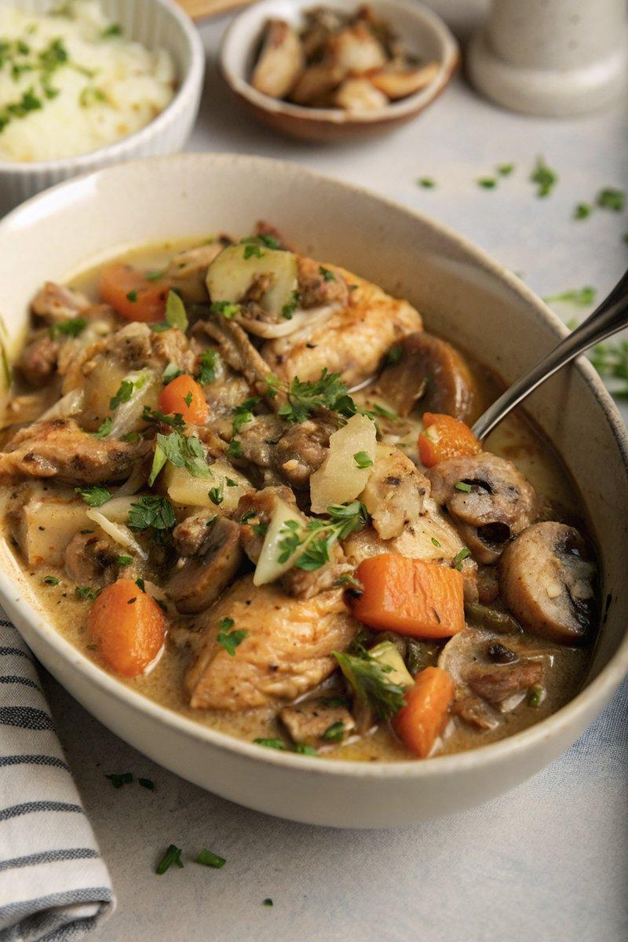

INGREDIENTS  - {'group': 'Main', 'item': '8 boneless chicken thigh fillets (720g), trimmed of fat'}  - {'group': 'Main', 'item': '2 tbsp sunflower oil'}  - {'group': 'Main', 'item': '2 small onions, peeled and diced'}  - {'group': 'Main', 'item': '3 garlic cloves, peeled and minced'}  - {'group': 'Main', 'item': '20 baby chestnut mushrooms'}  - {'group': 'Main', 'item': '20 Chantenay carrots, scrubbed'}  - {'group': 'Main', 'item': '3 celery sticks, roughly chopped'}  - {'group': 'Sauce', 'item': '2 tbsp unsalted butter'}  - {'group': 'Sauce', 'item': '3 tbsp plain flour'}  - {'group': 'Sauce', 'item': '1 tsp salt'}  - {'group': 'Sauce', 'item': '1 tsp ground black pepper'}  - {'group': 'Sauce', 'item': '1 tsp dried thyme'}  - {'group': 'Sauce', 'item': '½ tsp celery salt'}  - {'group': 'Sauce', 'item': '480 ml chicken stock'}  - {'group': 'Sauce', 'item': '1 tbsp lemon juice'}  - {'group': 'Sauce', 'item': '60 ml double cream'}  - {'group': 'Garnish', 'item': 'A small bunch of flat-leaf parsley, chopped'} | PREP  Trim the chicken thighs of excess fat. Dice the onions and mince the garlic. Scrub the carrots and roughly chop the celery.  COOK  Heat the sunflower oil in a large frying pan over medium-high heat. Brown the chicken thighs on both sides for about 5 minutes, then transfer them to a slow cooker. In the same pan, melt the butter and sauté the onions for 5 minutes until softened. Add the garlic and cook for another minute. Stir in the flour, salt, pepper, thyme, and celery salt, cooking for 2 minutes. Gradually add the chicken stock and lemon juice, stirring continuously until it boils. Pour this mixture over the chicken in the slow cooker. Add the mushrooms, carrots, and celery, stirring to combine. Cover and cook on low for 5-6 hours or on high for 3-4 hours. Once cooked, shred the chicken slightly with two forks and stir in the cream.  PLATING  Serve the casserole hot, garnished with chopped parsley.

NOTES:
For oven cooking, use a casserole dish at 175°C (350°F (175°C)) for 45-60 minutes, adding extra stock. This dish can be made ahead and reheated with a splash of cream or milk if needed.

