SLOW-COOKED BEEF RAGÙ  COOK TIME: 4 hrs  SOURCE: Unknown  #beef #Italian #slow-cook | 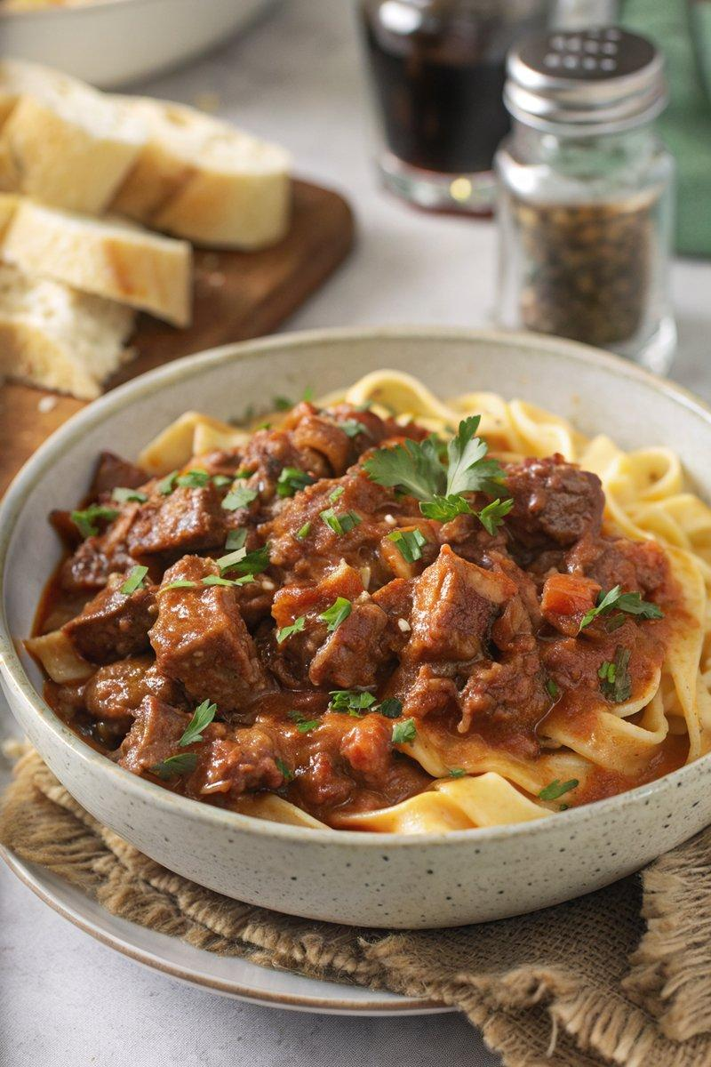

INGREDIENTS  - {'group': 'Main', 'item': '1kg braising beef (beef chuck), chopped'}  - {'group': 'Main', 'item': '3 heaped tbsp plain flour'}  - {'group': 'Main', 'item': '½ tsp salt'}  - {'group': 'Main', 'item': '½ tsp ground black pepper'}  - {'group': 'Main', 'item': '3 tbsp sunflower oil'}  - {'group': 'Main', 'item': '2 onions, peeled and chopped'}  - {'group': 'Main', 'item': '4 medium carrots, peeled and chopped into small chunks'}  - {'group': 'Main', 'item': '3 celery sticks, finely chopped'}  - {'group': 'Main', 'item': '3 garlic cloves, peeled and minced'}  - {'group': 'Sauce', 'item': '2 tbsp tomato purée'}  - {'group': 'Sauce', 'item': '300ml red wine'}  - {'group': 'Sauce', 'item': '2 x 400g cans chopped tomatoes'}  - {'group': 'Sauce', 'item': '600ml hot beef stock'}  - {'group': 'Seasoning', 'item': '1 tsp dried thyme'}  - {'group': 'For Serving', 'item': 'cooked pappardelle pasta'}  - {'group': 'For Serving', 'item': 'grated Parmesan'}  - {'group': 'For Serving', 'item': 'a small bunch of flat-leaf parsley, chopped'}  - {'group': 'For Serving', 'item': 'chunks of crusty bread'} | PREP  Preheat the oven to 160°C (320°F (160°C)). In a bowl, coat the chopped braising beef with flour, salt, and pepper.  COOK  Heat sunflower oil in a large casserole pan over medium-high heat. Brown the beef in batches, about 4-5 mins per batch. Return all beef to the pan, add onions, and cook over low heat until softened, about 3-4 mins. Stir in carrots, celery, and garlic, cooking for another 2 mins. Mix in tomato purée, then pour in red wine and increase heat to let it bubble for a couple of mins, scraping the pan. Add chopped tomatoes, beef stock, and thyme. Bring to a boil, cover, and transfer to the oven. Cook for 3-4 hrs until beef is tender, checking occasionally to ensure the sauce doesn't dry out, adding water if necessary.  PLATING  Serve the ragù over cooked pappardelle pasta, topped with grated Parmesan and chopped parsley. Accompany with chunks of crusty bread.

NOTES:
For slow cooker method, reduce beef stock to 480ml. Cook on low for 6-8 hrs or high for 4-5 hrs. The ragù can be made ahead, cooled, and refrigerated for up to 2 days.

