SPICED BEEF CHILLI WITH BEANS  COOK TIME: 1 hr 35 mins  SOURCE: Unknown  #beef #Mexican #slow-cook | 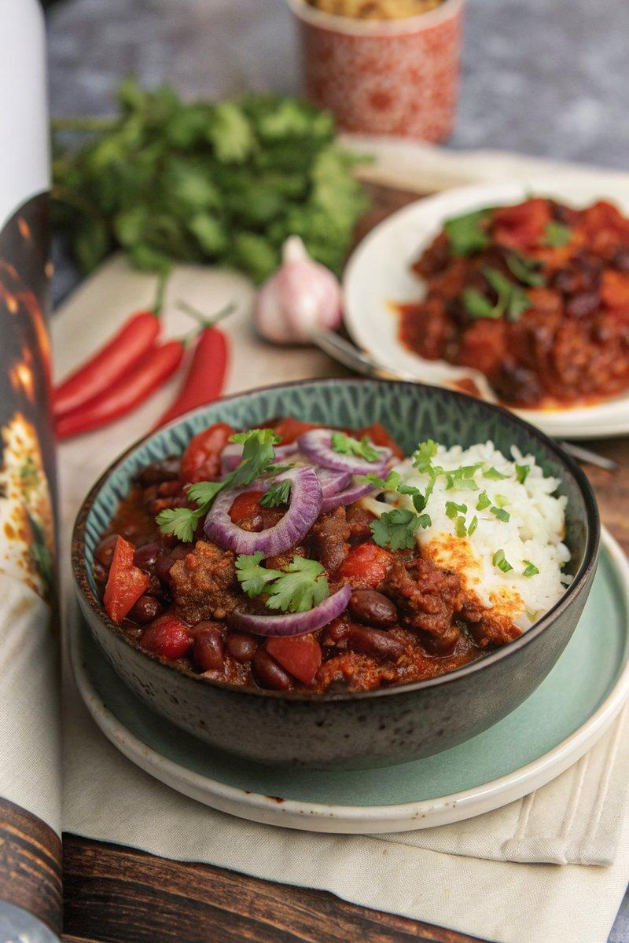

INGREDIENTS  - {'group': 'Main', 'item': '500g minced beef'}  - {'group': 'Main', 'item': '2 large onions, peeled and diced'}  - {'group': 'Main', 'item': '6 garlic cloves, peeled and minced'}  - {'group': 'Main', 'item': '2 red peppers, deseeded and chopped'}  - {'group': 'Main', 'item': '4 x 400g cans chopped tomatoes'}  - {'group': 'Main', 'item': '2 x 400g cans kidney beans, drained and rinsed'}  - {'group': 'Main', 'item': '1 x 420g can mixed beans, drained and rinsed'}  - {'group': 'Sauce', 'item': '360ml red wine'}  - {'group': 'Sauce', 'item': '180ml beef stock'}  - {'group': 'Sauce', 'item': '4 tbsp Worcestershire sauce'}  - {'group': 'Sauce', 'item': '2 tbsp honey'}  - {'group': 'Seasoning', 'item': '1 tsp smoked paprika'}  - {'group': 'Seasoning', 'item': '4 tsp ground cumin'}  - {'group': 'Seasoning', 'item': '2 tsp ground coriander'}  - {'group': 'Seasoning', 'item': '2 tsp hot chilli powder'}  - {'group': 'Seasoning', 'item': '3 tsp ground ginger'}  - {'group': 'Seasoning', 'item': '2 tsp mixed herbs'}  - {'group': 'Seasoning', 'item': '½ tsp salt'}  - {'group': 'Seasoning', 'item': '½ tsp ground black pepper'}  - {'group': 'Seasoning', 'item': '1 chopped chilli'}  - {'group': 'Sauce', 'item': '3 tbsp tomato purée'}  - {'group': 'Sauce', 'item': '1 tbsp tomato ketchup'}  - {'group': 'Sauce', 'item': '1 tsp chipotle paste'}  - {'group': 'Sauce', 'item': '2 chunks of 80% dark chocolate'}  - {'group': 'Garnish', 'item': 'A small bunch of fresh coriander, chopped'} | PREP  Dice the onions and chop the garlic. Deseed and chop the red peppers. Drain and rinse the kidney and mixed beans. Chop the fresh coriander for garnish.  COOK  Heat the sunflower oil in a large casserole pan over medium-high heat. Sauté the onions until soft and translucent, about 5-6 minutes. Add the garlic and cook for another minute. Stir in the minced beef, breaking it up with a spoon, and cook until browned. Pour in the red wine, bring to a simmer, and cook for 3 minutes. Add the beef stock, Worcestershire sauce, and honey, stirring well. Mix in the red peppers and canned tomatoes. Season with smoked paprika, cumin, ground coriander, chilli powder, ginger, mixed herbs, salt, pepper, and chopped chilli. Cook for 2-3 minutes. Stir in the tomato purée, ketchup, chipotle paste, and dark chocolate. Bring to a simmer, cover loosely, and cook for 1 hour. Add the kidney and mixed beans, stir, and simmer for an additional 20 minutes.  PLATING  Serve the chilli con carne hot, garnished with chopped coriander. Accompany with rice, sour cream, and chopped fresh chillies if desired.

NOTES:
This dish can be made ahead and tastes even better when reheated, allowing the flavours to develop. Store in the refrigerator for up to 2 days or freeze for longer storage. Reheat thoroughly before serving.

