SLOW-COOKED BEEF BOURGUIGNON  COOK TIME: 3 hrs 40 mins  SOURCE: Unknown  #beef #French #braise | 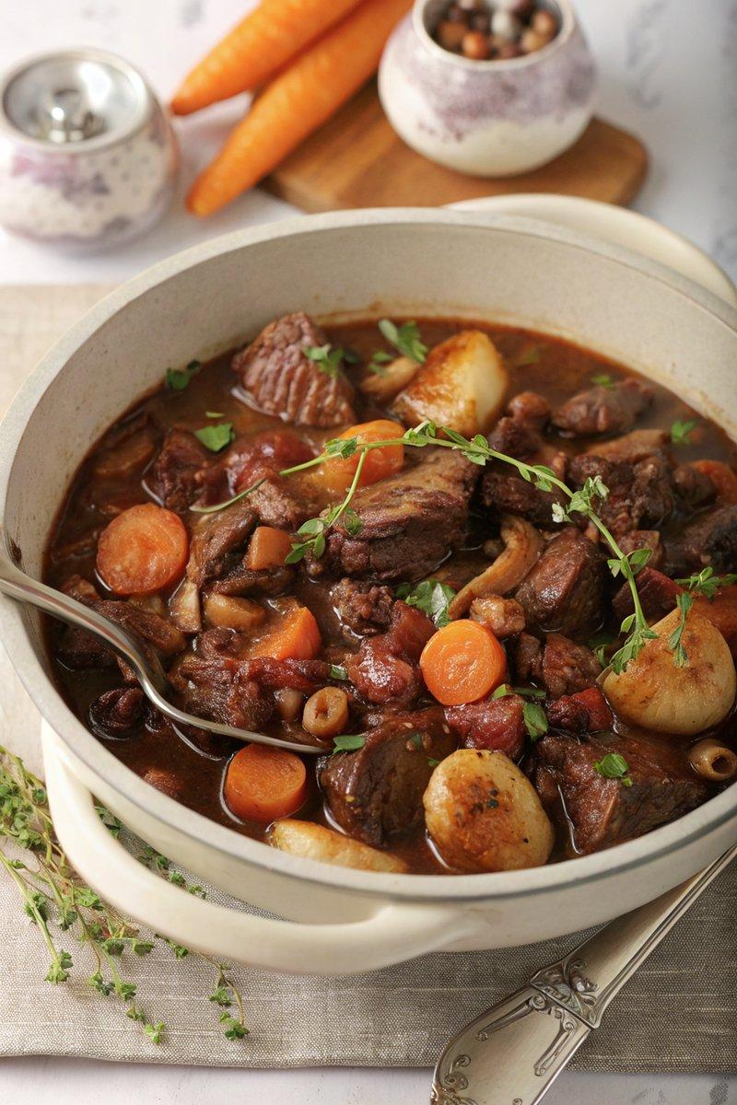

INGREDIENTS  - {'group': 'Main', 'item': '1.4kg beef braising steak, cut into large chunks'}  - {'group': 'Main', 'item': '120g bacon lardons'}  - {'group': 'Main', 'item': '20 small shallots, peeled, 6 halved'}  - {'group': 'Main', 'item': '16-20 Chantenay carrots, peeled or scrubbed'}  - {'group': 'Main', 'item': '150g chestnut mushrooms, thickly sliced'}  - {'group': 'Sauce', 'item': '1 tbsp sunflower oil'}  - {'group': 'Sauce', 'item': '3 tbsp plain flour'}  - {'group': 'Sauce', 'item': '1/2 tsp salt'}  - {'group': 'Sauce', 'item': '1/2 tsp ground black pepper'}  - {'group': 'Sauce', 'item': '1 tbsp tomato purée'}  - {'group': 'Sauce', 'item': '750ml red wine'}  - {'group': 'Sauce', 'item': '240ml beef stock'}  - {'group': 'Seasoning', 'item': '3 bay leaves'}  - {'group': 'Seasoning', 'item': '1 tsp dried thyme'} | PREP  Preheat the oven to 160°C (320°F (160°C)). Peel the shallots, halving six of them, and prepare the carrots and mushrooms. Cut the beef into large chunks.  COOK  Heat sunflower oil in a large ovenproof casserole dish over medium heat. Fry the bacon lardons until golden, then remove. Sear the halved shallots in the same dish until browned, then remove. Toss the beef chunks in flour, salt, and pepper. Brown the beef in batches, transferring each batch to a bowl. Return all beef to the dish, stir in tomato purée, then add red wine, beef stock, bay leaves, thyme, carrots, mushrooms, and whole shallots. Bring to a boil, cover, and transfer to the oven. Cook for 3 hours, checking occasionally to ensure it doesn't dry out, adding water if necessary.  PLATING  After 3 hours, stir in the reserved bacon lardons and seared shallots. Return to the oven for an additional 10 minutes. Serve hot with mashed potatoes or crusty bread.

NOTES:
Use a reasonably priced red wine as the flavour will mellow during cooking. Avoid overly vinegary wines.

