STEAK DIANE BEEF CASSEROLE  COOK TIME: 3 hrs 20 mins  SOURCE: Unknown  #beef #American #slow-cook | 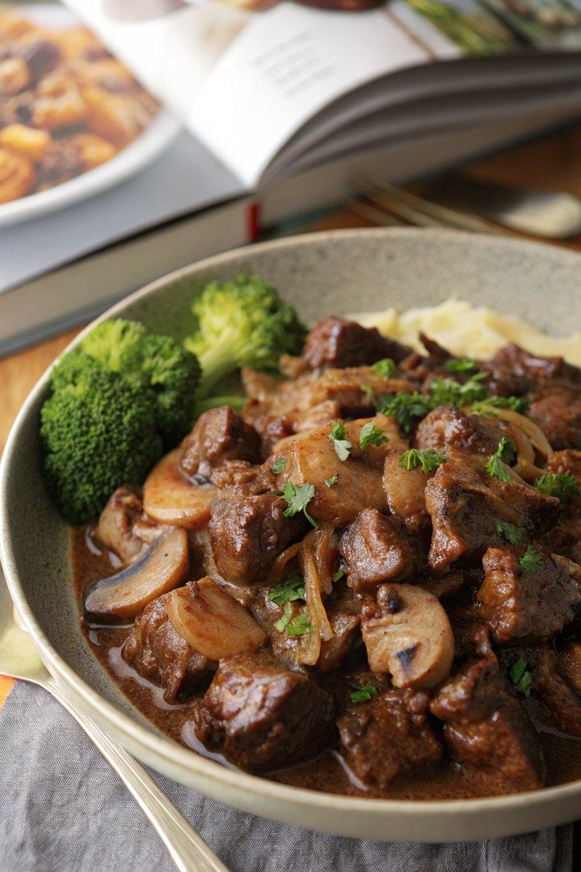

INGREDIENTS  - {'group': 'Main', 'item': '1.5kg braising beef, chopped into bite-size chunks'}  - {'group': 'Main', 'item': '2 tbsp sunflower oil'}  - {'group': 'Main', 'item': '1 large onion, peeled and chopped'}  - {'group': 'Main', 'item': '4 garlic cloves, peeled and minced'}  - {'group': 'Main', 'item': '300g chestnut mushrooms, thickly sliced'}  - {'group': 'Sauce', 'item': '3 tbsp plain flour'}  - {'group': 'Sauce', 'item': '1/2 tsp salt'}  - {'group': 'Sauce', 'item': '1/2 tsp ground black pepper'}  - {'group': 'Sauce', 'item': '2 tbsp tomato purée'}  - {'group': 'Sauce', 'item': '4 tbsp brandy or whisky'}  - {'group': 'Sauce', 'item': '1 tbsp Worcestershire sauce'}  - {'group': 'Sauce', 'item': '1L beef stock'}  - {'group': 'Thickening', 'item': '1 tbsp cornflour mixed with 3 tbsp cold water (optional)'}  - {'group': 'Finishing', 'item': '120 ml double cream'}  - {'group': 'Garnish', 'item': 'Chopped flat-leaf parsley'} | PREP  Preheat the oven to 160°C (320°F (160°C)). Toss the beef chunks in a bowl with flour, salt, and pepper until evenly coated. Prepare the onion, garlic, and mushrooms by chopping and slicing as needed.  COOK  Heat sunflower oil in a large casserole pan over high heat. Brown the beef in the pan for 6-8 mins, turning regularly. Reduce heat to medium, add the onion, and cook for 3-4 mins until softened. Stir in garlic and tomato purée, cooking for another minute. Pour in brandy, Worcestershire sauce, beef stock, and mushrooms, stirring to combine. Bring to a boil, cover, and transfer to the oven. Cook for 3 hours, checking occasionally to ensure it doesn't dry out, adding boiling water if necessary.  PLATING  Remove from oven and stir in the cornflour slurry if a thicker sauce is desired. Add double cream and mix well. Garnish with chopped parsley and serve with mashed potatoes and green vegetables.

NOTES:
For a slow cooker option, transfer the boiled mixture to a slow cooker and cook on high for 5-6 hours or low for 7-8 hours. The casserole can be made ahead, cooled, and refrigerated. Reheat in the oven at 160°C (320°F (160°C)) for 35-45 mins until hot.

