SLOW-COOKED BEEF SHORT RIBS WITH RED WINE GRAVY  COOK TIME: 8 hrs  SOURCE: Unknown  #beef #American #slow-cook | 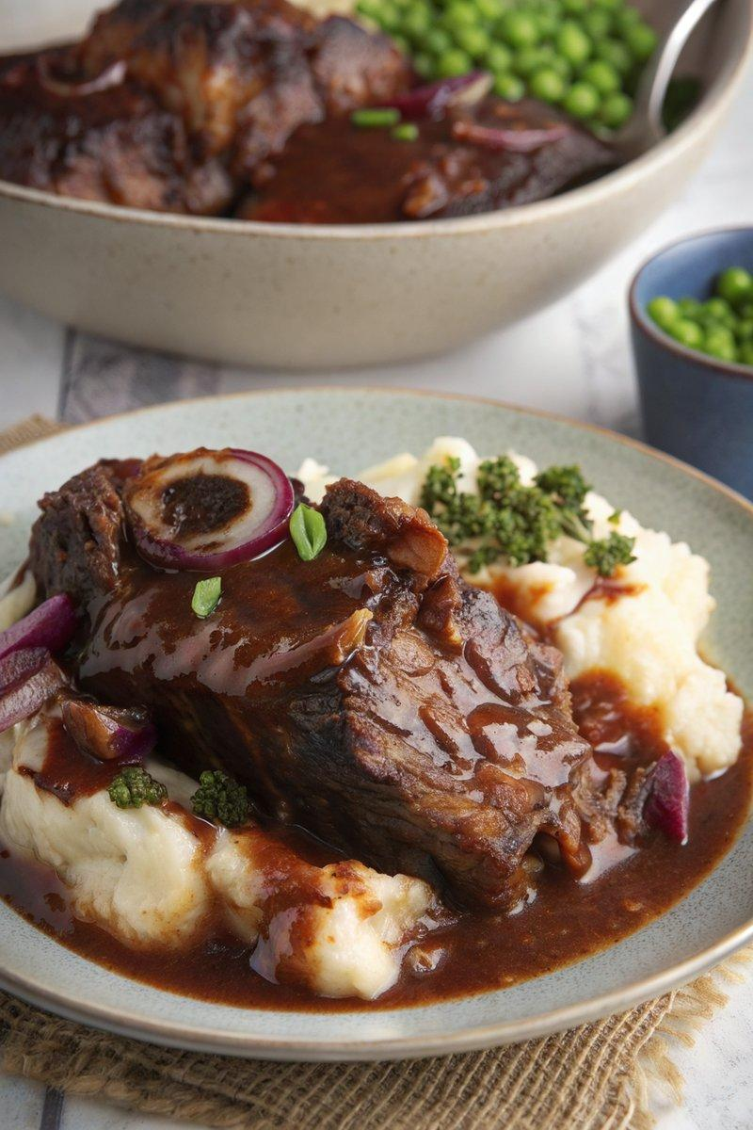

INGREDIENTS  - {'group': 'Main', 'item': '4 beef short ribs'}  - {'group': 'Main', 'item': '1 tbsp sunflower oil'}  - {'group': 'Main', 'item': '1 onion, chopped'}  - {'group': 'Main', 'item': '3 garlic cloves, minced'}  - {'group': 'Sauce', 'item': '240ml red wine'}  - {'group': 'Sauce', 'item': '640ml beef stock'}  - {'group': 'Sauce', 'item': '1 tsp dried thyme'}  - {'group': 'Sauce', 'item': '1 tbsp tomato purée'}  - {'group': 'Sauce', 'item': '1 tsp sugar'}  - {'group': 'Sauce', 'item': '2 bay leaves'}  - {'group': 'Seasoning', 'item': '¼ tsp salt'}  - {'group': 'Seasoning', 'item': '¼ tsp ground black pepper'}  - {'group': 'Sauce', 'item': '1 tbsp Worcestershire sauce'}  - {'group': 'Thickener', 'item': '2 tbsp cornflour mixed with 5 tbsp cold water'} | PREP  Chop the onion and mince the garlic. Prepare the cornflour slurry by mixing cornflour with cold water.  COOK  Heat sunflower oil in a frying pan over high heat. Brown the beef short ribs on all sides, about 10 mins. Reduce heat to medium, add chopped onion, and cook for 2 mins. Stir in minced garlic and cook for 1 min. Pour in red wine, bring to a simmer, and cook for 3-4 mins. Add beef stock, thyme, tomato purée, sugar, bay leaves, salt, pepper, and Worcestershire sauce. Bring to a boil, then transfer everything to a slow cooker. Cover and cook on low for 6-8 hrs until the beef is tender.  PLATING  Remove the ribs from the slow cooker. Strain the cooking liquid into a saucepan. Over high heat, whisk in the cornflour slurry until the gravy thickens to a medium consistency. Serve the ribs with the gravy, alongside creamy mashed potatoes and green vegetables.

NOTES:
Leftovers can be used in burritos. To make ahead, cool the cooked ribs in their liquid, refrigerate for up to 2 days, and reheat in the oven at 160°C (320°F (160°C)) for 30-40 mins.

