SLOW-COOKED PORK WITH MUSHROOMS  COOK TIME: 6 hrs 15 mins  SOURCE: Unknown  #pork #American #slow-cook | 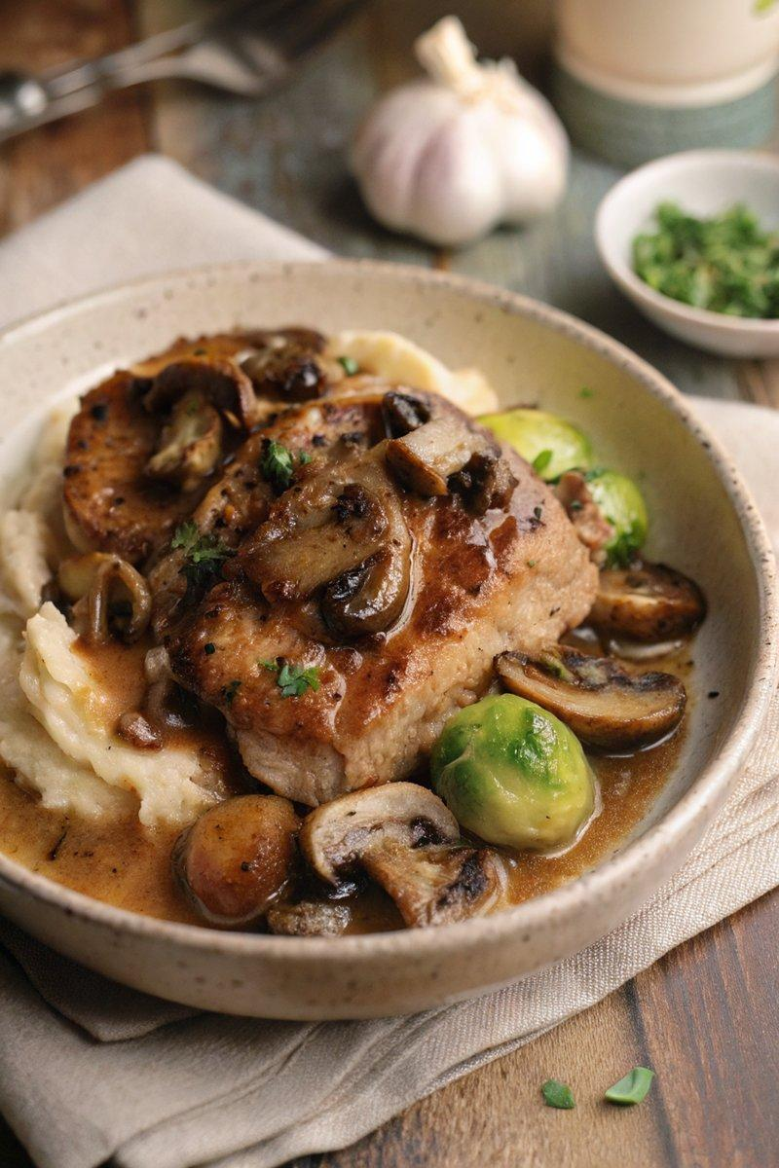

INGREDIENTS  - {'group': 'Main', 'item': '4 thick boneless pork shoulder or loin steaks'}  - {'group': 'Main', 'item': '3 tbsp olive oil'}  - {'group': 'Main', 'item': '1 large onion, thinly sliced'}  - {'group': 'Main', 'item': '3 garlic cloves, minced'}  - {'group': 'Main', 'item': '200g mushrooms, sliced'}  - {'group': 'Sauce', 'item': '2 tbsp plain flour'}  - {'group': 'Sauce', 'item': '360 ml chicken stock'}  - {'group': 'Sauce', 'item': '1/2 tbsp tomato purée'}  - {'group': 'Sauce', 'item': '1/2 tbsp white wine vinegar'}  - {'group': 'Sauce', 'item': '60 ml double cream'}  - {'group': 'Seasoning', 'item': '1/4 tsp salt'}  - {'group': 'Seasoning', 'item': '1/2 tsp ground black pepper'}  - {'group': 'Garnish', 'item': '2 tbsp chopped flat-leaf parsley'} | PREP  Thinly slice the onion and mushrooms. Mince the garlic. Season the pork steaks with salt and half of the pepper.  COOK  Heat 2 tbsp of olive oil in a frying pan over high heat. Sear the pork steaks for 2 mins on each side until browned, then transfer to a slow cooker. In the same pan, add the remaining oil and reduce heat to medium. Sauté the onion for 5 mins until softened, then add garlic and cook for another minute. Stir in the flour to coat the onion and garlic, then gradually add the chicken stock, stirring continuously. Pour this mixture into the slow cooker. Add mushrooms, tomato purée, white wine vinegar, and remaining pepper. Cover and cook on high for 3-4 hrs or low for 5-6 hrs.  PLATING  Stir in the cream just before serving. Garnish with chopped parsley. Serve with mashed potatoes and green vegetables.

NOTES:
For added flavour, consider adding chunks of potato, courgette, baby carrots, or green beans to the slow cooker.

