CREAMY PORK CASSEROLE WITH CIDER AND MUSHROOMS  COOK TIME: 3 hrs 20 mins  SOURCE: Unknown  #pork #British #slow-cook | 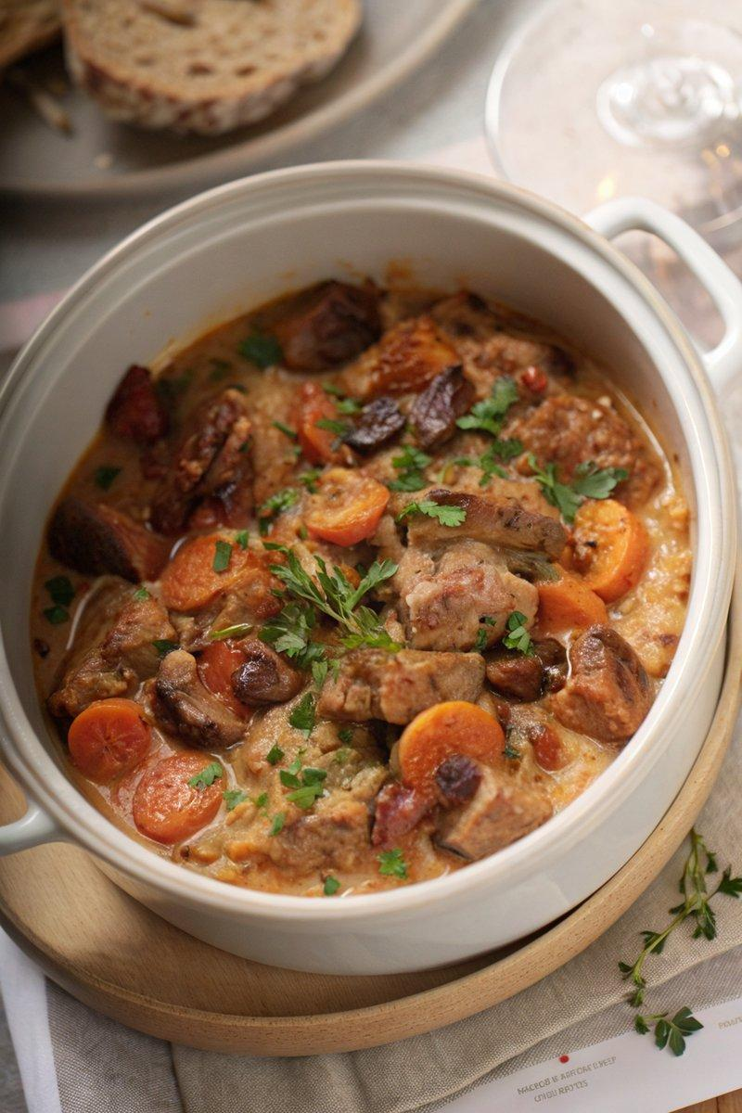

INGREDIENTS  - {'group': 'Main', 'item': '500g diced pork shoulder'}  - {'group': 'Main', 'item': '2 tbsp sunflower oil'}  - {'group': 'Main', 'item': '1 onion, peeled and chopped'}  - {'group': 'Main', 'item': '12 baby mushrooms, halved'}  - {'group': 'Main', 'item': '2 carrots, peeled and roughly chopped'}  - {'group': 'Main', 'item': '250ml dry cider'}  - {'group': 'Main', 'item': '420ml chicken stock'}  - {'group': 'Main', 'item': '½ tsp dried thyme'}  - {'group': 'Main', 'item': '¼ tsp salt'}  - {'group': 'Main', 'item': '¼ tsp ground black pepper'}  - {'group': 'Main', 'item': '¼ tsp celery salt'}  - {'group': 'Garnish', 'item': '150g bacon lardons'}  - {'group': 'Garnish', 'item': 'Chopped flat-leaf parsley'}  - {'group': 'Thickener', 'item': '1 tbsp cornflour mixed with 3 tbsp cold water'}  - {'group': 'Sauce', 'item': '60ml double cream'} | PREP  Preheat the oven to 170°C (340°F (171°C)). Toss the diced pork shoulder with salt, pepper, and celery salt in a bowl.  COOK  Heat 1 tbsp of sunflower oil in a large ovenproof casserole dish over high heat. Brown the pork on all sides for 6-8 mins. Reduce the heat to medium, add the chopped onion, and cook for 5 mins until softened. Stir in the mushrooms and cook for another 2 mins. Add the carrots, cider, chicken stock, and thyme. Increase the heat to bring the mixture to a boil, scraping up any browned bits from the bottom of the pan. Cover with a lid and transfer to the oven. Cook for 2-3 hours until the pork is tender and breaks apart easily.  PLATING  Ten minutes before the casserole is done, fry the bacon lardons in the remaining oil until crispy. Remove the casserole from the oven, stir in the cornflour slurry to thicken, and then add the cream. Top with crispy bacon and chopped parsley before serving.

NOTES:
For a slow cooker version, cook on low for 6-8 hours or high for 4-5 hours. This dish can be made ahead and reheated in the oven or on the stovetop.

