SLOW-COOKED RASPBERRY JAM SPONGE  COOK TIME: 2 hrs 30 mins  SOURCE: Unknown  #dessert #British #slow-cook | 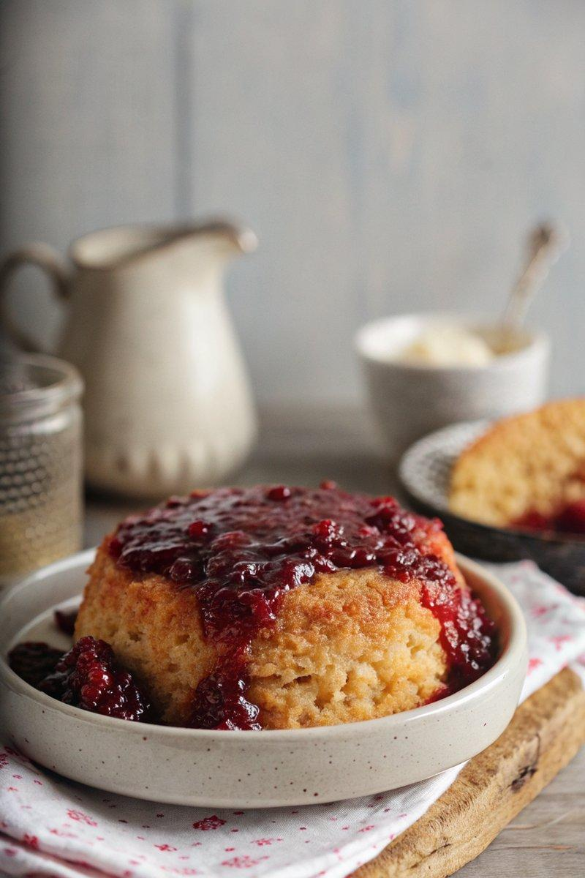

INGREDIENTS  - {'group': 'Main', 'item': '½ tsp soft unsalted butter, for greasing'}  - {'group': 'Main', 'item': '180g unsalted butter, softened'}  - {'group': 'Main', 'item': '180g caster sugar'}  - {'group': 'Main', 'item': '3 medium eggs'}  - {'group': 'Main', 'item': '1 tbsp milk'}  - {'group': 'Main', 'item': '1 tsp vanilla extract'}  - {'group': 'Main', 'item': '180g plain flour'}  - {'group': 'Main', 'item': '2 tsp baking powder'}  - {'group': 'Main', 'item': '7 tbsp raspberry jam'} | PREP  Grease a 1.2L pudding basin with butter. In a large bowl, cream the softened butter and caster sugar until light and fluffy. Gradually add the eggs, one at a time, mixing well after each addition. Stir in the milk and vanilla extract. Gently fold in the flour and baking powder until just combined.  COOK  Preheat the slow cooker on high. Spoon the raspberry jam into the bottom of the greased pudding basin. Carefully pour the batter over the jam. Cover the basin with a pleated piece of baking parchment, securing it with string. Place the basin in the slow cooker and pour boiling water into the cooker until it reaches three-quarters up the sides of the basin. Cover and cook on high for 2½ hours.  PLATING  Once cooked, carefully remove the pudding basin from the slow cooker. Remove the string and parchment. Invert the pudding onto a plate, allowing the jam to cascade over the sponge. Serve warm with cream, custard, or ice cream.

NOTES:
For variety, try using different jams such as strawberry or marmalade.

