CREAMY TOMATO RISOTTO WITH GARLIC CRUMBS  COOK TIME: 40 mins  SOURCE: Unknown  #vegetarian #Italian #risotto | 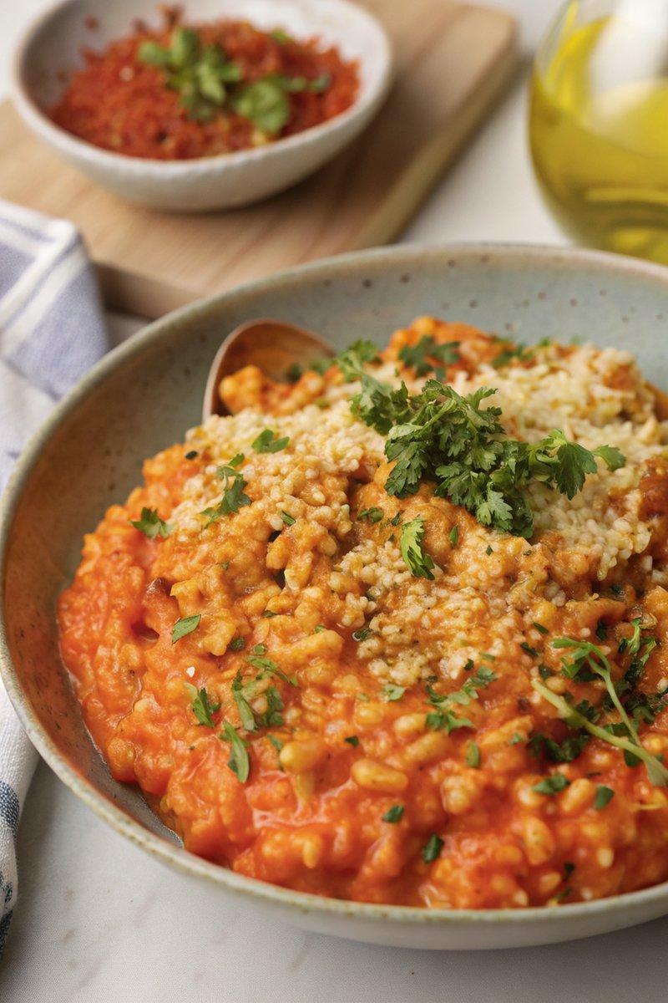

INGREDIENTS  - {'group': 'Main', 'item': '400g can finely chopped tomatoes'}  - {'group': 'Main', 'item': '240ml vegetable stock'}  - {'group': 'Main', 'item': '2 tbsp tomato purée'}  - {'group': 'Main', 'item': '1 tbsp olive oil'}  - {'group': 'Main', 'item': '1 small onion, finely chopped'}  - {'group': 'Main', 'item': '1 garlic clove, minced'}  - {'group': 'Main', 'item': '150g Arborio rice'}  - {'group': 'Main', 'item': '120ml white wine'}  - {'group': 'Main', 'item': '3 tbsp double cream'}  - {'group': 'Main', 'item': '4 tbsp grated Parmesan'}  - {'group': 'Main', 'item': '1 tbsp lemon juice'}  - {'group': 'Main', 'item': '¼ tsp salt'}  - {'group': 'Main', 'item': '¼ tsp ground black pepper'}  - {'group': 'Garlic Crumbs', 'item': '1 tbsp unsalted butter'}  - {'group': 'Garlic Crumbs', 'item': '¼ tsp Maldon salt'}  - {'group': 'Garlic Crumbs', 'item': '2 garlic cloves, minced'}  - {'group': 'Garlic Crumbs', 'item': '4 tbsp panko breadcrumbs'}  - {'group': 'Garlic Crumbs', 'item': '1 tsp chopped flat-leaf parsley'}  - {'group': 'Garlic Crumbs', 'item': 'zest of ½ lemon'}  - {'group': 'Garlic Crumbs', 'item': '3 tbsp grated Parmesan'} | PREP  Finely chop the onion and mince the garlic. Measure out the Arborio rice, white wine, and vegetable stock. Zest half a lemon and chop the parsley for the garlic crumbs.  COOK  In a saucepan, combine the chopped tomatoes, vegetable stock, and tomato purée. Heat until almost boiling, then remove from heat. In a large frying pan, heat olive oil and sauté the onion for 5 mins until softened. Add minced garlic and cook for 1 min. Stir in Arborio rice until coated with oil, then pour in white wine. Stir until wine is nearly absorbed. Gradually add tomato stock, one ladle at a time, allowing each to be absorbed before adding more. Cook for 15-20 mins until rice is tender with a slight bite. Meanwhile, in a small pan, melt butter and add salt and minced garlic, cooking for 30 secs. Stir in panko breadcrumbs and cook until golden. Remove from heat and mix in parsley, lemon zest, and Parmesan.  PLATING  Stir cream, Parmesan, lemon juice, salt, and pepper into the risotto. Serve topped with garlic crumbs.

NOTES:
For a vegetarian version, use vegetarian Parmesan or Italian-style hard cheese.

