PAN-FRIED SALMON WITH CREAMY WHITE WINE SAUCE  COOK TIME: 10 mins  SOURCE: Unknown  #salmon #French #pan-fry | 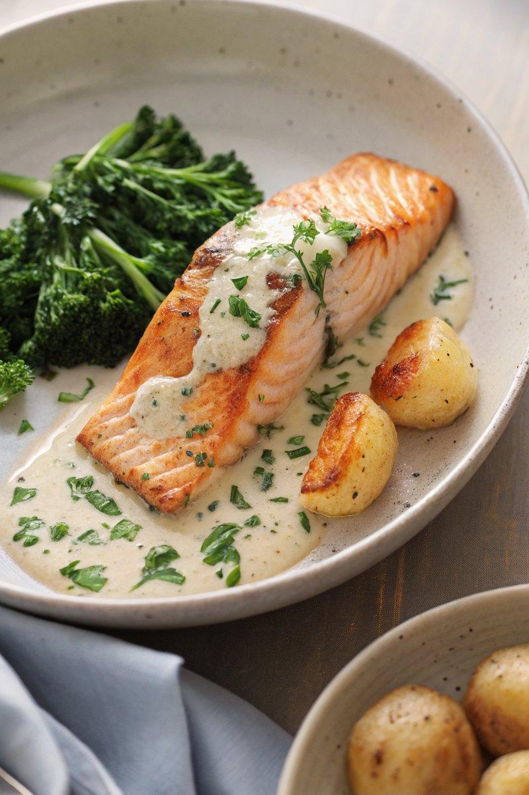

INGREDIENTS  - {'group': 'Main', 'item': '2 skin-on salmon fillets'}  - {'group': 'Main', 'item': '1 tbsp sunflower oil'}  - {'group': 'Sauce', 'item': '1 garlic clove, minced'}  - {'group': 'Sauce', 'item': '60 ml white wine'}  - {'group': 'Sauce', 'item': '60 ml strong chicken stock'}  - {'group': 'Sauce', 'item': '180 ml double cream'}  - {'group': 'Seasoning', 'item': '1/4 tsp salt'}  - {'group': 'Seasoning', 'item': '1/4 tsp ground black pepper'}  - {'group': 'Sauce', 'item': '3 tbsp grated Parmesan'}  - {'group': 'Garnish', 'item': 'Zest of 1 lemon'}  - {'group': 'Garnish', 'item': '1 tbsp chopped flat-leaf parsley'} | PREP  Mince the garlic and zest the lemon. Chop the parsley and set aside.  COOK  Heat the sunflower oil in a frying pan over high heat. Place the salmon fillets skin-side down and cook for 2 minutes. Flip the fillets and cook for another 2 minutes until lightly browned, then turn back to skin-side down. Reduce the heat to medium, add the minced garlic, and sauté for 30 seconds. Pour in the white wine, bring to a boil, and let it bubble for a minute. Add the chicken stock and continue to bubble for another minute. Stir in the cream, salt, pepper, and Parmesan, bringing the mixture back to a boil. Simmer gently for 3-4 minutes until the sauce thickens and the salmon is cooked through.  PLATING  Transfer the salmon to plates, spoon the creamy sauce over the top, and sprinkle with lemon zest and parsley. Serve with baby new potatoes and steamed broccoli.

NOTES:
Using skin-on salmon helps prevent overcooking. The skin can be easily removed after cooking if preferred.

