TUSCAN CHICKEN IN CREAMY SUN-DRIED TOMATO SAUCE  COOK TIME: 15 mins  SOURCE: Unknown  #chicken #Italian #pan-fry | 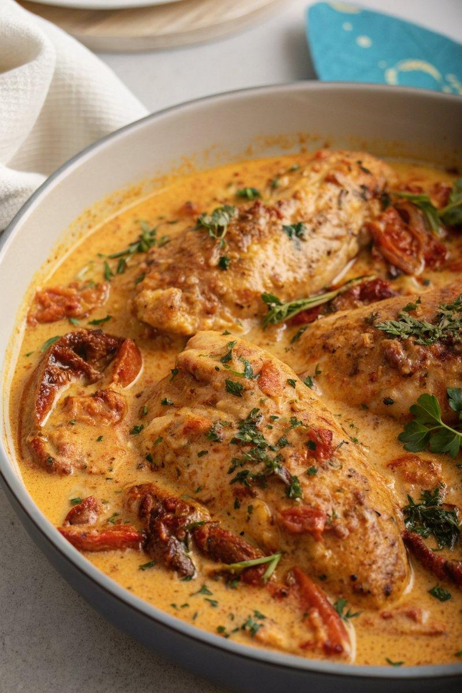

INGREDIENTS  - {'group': 'Main', 'item': '4 chicken breasts'}  - {'group': 'Coating', 'item': '1 large egg, lightly whisked'}  - {'group': 'Coating', 'item': '3 tbsp plain flour'}  - {'group': 'Coating', 'item': '1/4 tsp salt'}  - {'group': 'Coating', 'item': '1/2 tsp ground black pepper'}  - {'group': 'Coating', 'item': '1/2 tsp dried oregano'}  - {'group': 'Coating', 'item': '1/2 tsp dried thyme'}  - {'group': 'Coating', 'item': '1/2 tsp paprika'}  - {'group': 'Coating', 'item': '1/4 tsp garlic salt'}  - {'group': 'Sauce', 'item': '3 tbsp olive oil'}  - {'group': 'Sauce', 'item': '1 onion, sliced'}  - {'group': 'Sauce', 'item': '2 garlic cloves, minced'}  - {'group': 'Sauce', 'item': '1/2 tsp dried oregano'}  - {'group': 'Sauce', 'item': '1 tsp paprika'}  - {'group': 'Sauce', 'item': '160g sun-dried tomatoes'}  - {'group': 'Sauce', 'item': '1 red bell pepper, sliced'}  - {'group': 'Sauce', 'item': '1 tbsp tomato purée'}  - {'group': 'Sauce', 'item': '90 ml white wine'}  - {'group': 'Sauce', 'item': '240 ml chicken stock'}  - {'group': 'Sauce', 'item': 'a pinch of salt and pepper'}  - {'group': 'Sauce', 'item': '90 ml double cream'}  - {'group': 'Sauce', 'item': '50g grated Parmesan'}  - {'group': 'Sauce', 'item': '90g baby spinach'}  - {'group': 'Garnish', 'item': '1 tbsp chopped flat-leaf parsley'} | PREP  Preheat the oven to 160°C (320°F (160°C)). Lightly whisk the egg in a shallow bowl. In another bowl, combine flour, salt, pepper, oregano, thyme, paprika, and garlic salt. Coat each chicken breast in the egg, then dredge in the flour mixture.  COOK  Heat 2 tbsp of olive oil in a large frying pan over medium-high heat. Fry the chicken until golden on both sides, then transfer to an oven tray and bake for 10 mins. In the same pan, add the remaining oil and sauté the onion for 3-4 mins. Add garlic, oregano, paprika, sun-dried tomatoes, red pepper, and tomato purée, cooking for 2 mins. Pour in the wine, let it bubble for 2 mins, then add chicken stock and simmer for 5 mins. Stir in cream, Parmesan, and spinach, cooking until the spinach wilts.  PLATING  Remove chicken from the oven, ensuring it's cooked through. Add to the pan, coating with sauce. Serve with a sprinkle of parsley, alongside pasta or crusty bread.

NOTES:
For a make-ahead option, prepare the dish, cool, and refrigerate for up to a day. Reheat thoroughly before serving, adding a splash of cream or stock if needed.

