CREAMY BEEF STROGANOFF WITH MUSHROOMS  COOK TIME: 15 mins  SOURCE: Unknown  #beef #European #pan-fry | 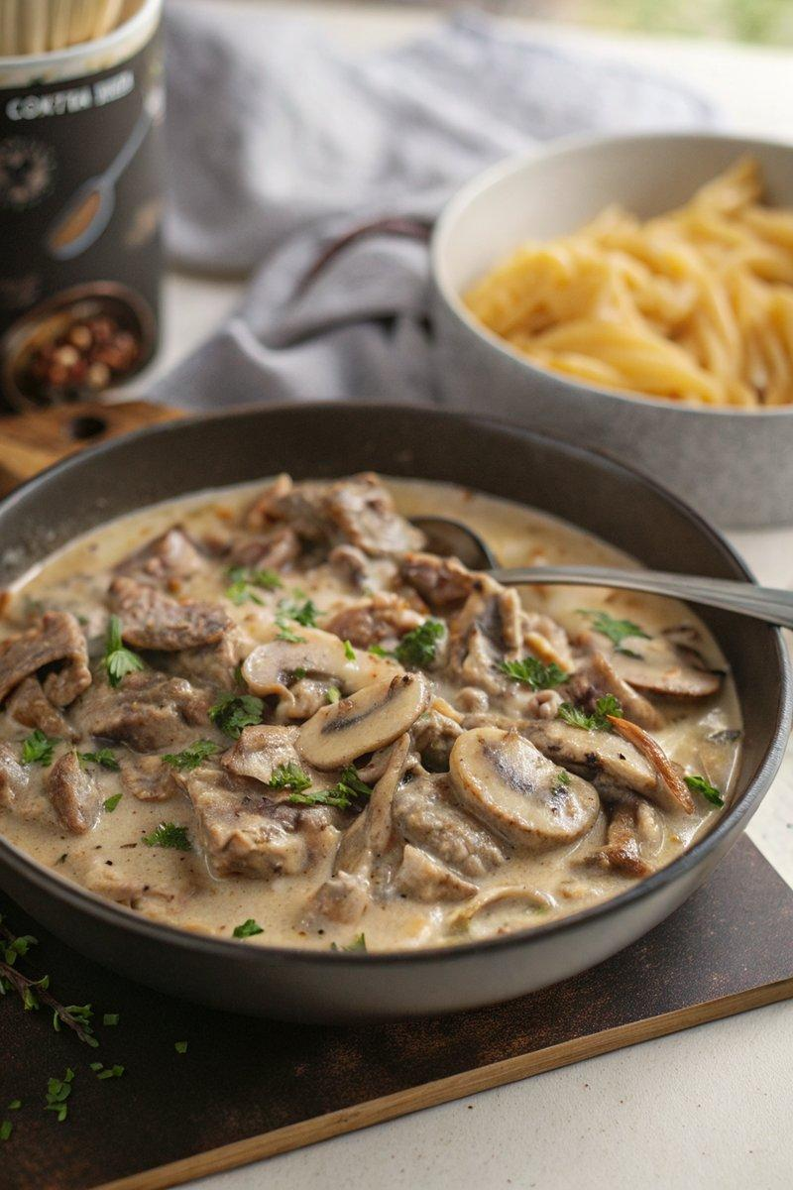

INGREDIENTS  - {'group': 'Main', 'item': '1 tbsp unsalted butter'}  - {'group': 'Main', 'item': '2 tbsp olive oil'}  - {'group': 'Main', 'item': '1 onion, peeled and finely sliced'}  - {'group': 'Main', 'item': '200g baby chestnut mushrooms, thickly sliced'}  - {'group': 'Main', 'item': '400g rib-eye steak, sliced into 1cm strips'}  - {'group': 'Seasoning', 'item': '1/4 tsp salt'}  - {'group': 'Seasoning', 'item': '1/4 tsp ground black pepper'}  - {'group': 'Sauce', 'item': '240ml double cream'}  - {'group': 'Sauce', 'item': '160ml sour cream'}  - {'group': 'Garnish', 'item': '1 tsp paprika'}  - {'group': 'Garnish', 'item': 'Chopped flat-leaf parsley'} | PREP  Slice the onion finely and cut the mushrooms into thick slices. Slice the rib-eye steak into 1cm strips.  COOK  Heat the butter and half the olive oil in a large frying pan over medium-high heat until the butter foams. Add the onion and cook for 5 minutes, stirring often, until softened. Add the mushrooms and cook for another 3-4 minutes until lightly browned. Remove the onion and mushrooms from the pan and set aside. Increase the heat to high, drizzle the steak strips with the remaining oil, and season with salt and pepper. Sear the steak in the pan for 1 minute on one side, then flip and cook for an additional 30 seconds. Return the onion and mushrooms to the pan, reduce the heat to medium, and stir in the double cream and sour cream. Heat gently until the sauce is hot and just begins to bubble at the edges, without boiling.  PLATING  Serve the Beef Stroganoff over cooked rice or pasta. Sprinkle with paprika and chopped parsley before serving.

NOTES:
For best results, use rib-eye, sirloin, or fillet steak for a tender and flavorful dish. Avoid boiling the sauce to maintain its creamy texture.

