SWEDISH MEATBALLS WITH CREAMY SAUCE  COOK TIME: 25 mins  SOURCE: Unknown  #beef #pork #Swedish #pan-fry | 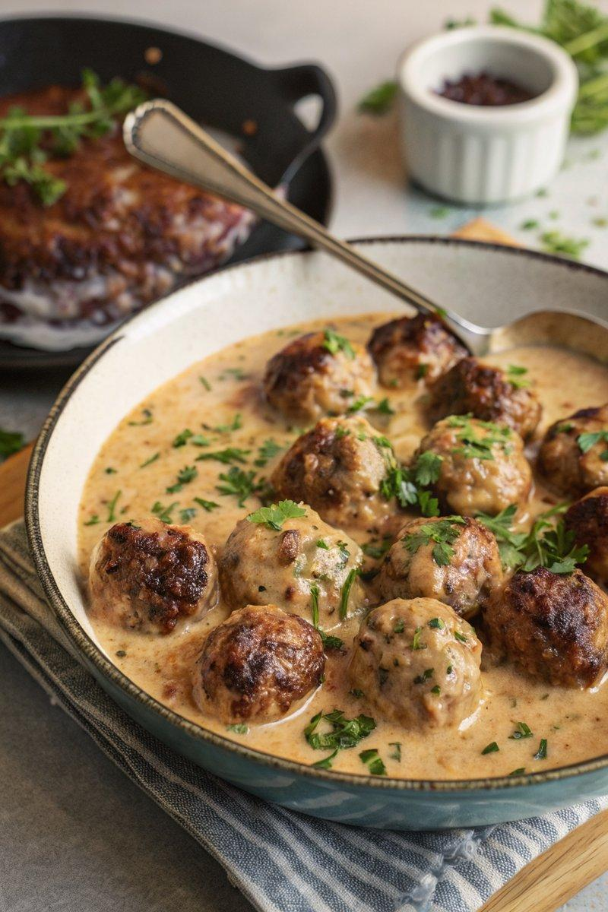

INGREDIENTS  - {'group': 'Main', 'item': '500g beef mince (20% fat)'}  - {'group': 'Main', 'item': '250g pork mince'}  - {'group': 'Main', 'item': '1 onion, finely chopped'}  - {'group': 'Main', 'item': '1 garlic clove, minced'}  - {'group': 'Main', 'item': '4 tbsp panko breadcrumbs'}  - {'group': 'Main', 'item': '1 medium egg'}  - {'group': 'Main', 'item': '5 tbsp milk'}  - {'group': 'Main', 'item': '½ tsp salt'}  - {'group': 'Main', 'item': '¼ tsp ground black pepper'}  - {'group': 'Main', 'item': '¼ tsp white pepper'}  - {'group': 'Main', 'item': '¼ tsp allspice'}  - {'group': 'Sauce', 'item': '3 tbsp unsalted butter'}  - {'group': 'Sauce', 'item': '3 tbsp plain flour'}  - {'group': 'Sauce', 'item': '180ml beef stock'}  - {'group': 'Sauce', 'item': '120ml vegetable stock'}  - {'group': 'Sauce', 'item': '120ml double cream'}  - {'group': 'Sauce', 'item': '2 tsp dark soy sauce'}  - {'group': 'Sauce', 'item': '1 tsp Worcestershire sauce'}  - {'group': 'Sauce', 'item': '1 tsp Dijon mustard'}  - {'group': 'Sauce', 'item': '1 tsp salt'}  - {'group': 'For Serving', 'item': 'Finely chopped flat-leaf parsley'}  - {'group': 'For Serving', 'item': 'Creamy mashed potato'}  - {'group': 'For Serving', 'item': 'Lingonberry jam or red currant jelly'}  - {'group': 'For Serving', 'item': 'Green vegetables, such as broccoli or green beans'} | PREP  In a large bowl, combine the beef mince, pork mince, onion, garlic, breadcrumbs, egg, milk, salt, black pepper, white pepper, and allspice. Mix thoroughly with your hands and shape into 18-22 meatballs.  COOK  Preheat the oven to 150°C (300°F (150°C)). Heat 1 tbsp of oil in a large frying pan over medium-high heat. Fry the meatballs in batches until browned on all sides, then transfer to a roasting tray. Place the tray in the oven for 5-6 mins to finish cooking. In the same pan, melt the butter over medium heat, then whisk in the flour to form a roux. Gradually add the beef stock, stirring until smooth. Incorporate the vegetable stock, bring to a boil, then add the cream, soy sauce, Worcestershire sauce, mustard, and salt. Return the meatballs to the pan, coat with the sauce, and cook for an additional 3-4 mins.  PLATING  Serve the meatballs with creamy mashed potatoes, a dollop of lingonberry jam, and green vegetables. Garnish with finely chopped parsley.

NOTES:
To make ahead, cool and store the meatballs and sauce separately. Reheat the meatballs in the oven at 180°C (350°F (175°C)) for 20 mins, covering with foil for the first 10 mins. Reheat the sauce in a pan until hot, then combine with the meatballs.

