ROAST LEG OF LAMB WITH VEGETABLES  COOK TIME: 2 hours 10 mins  SOURCE: Unknown  #lamb #Mediterranean #roast | 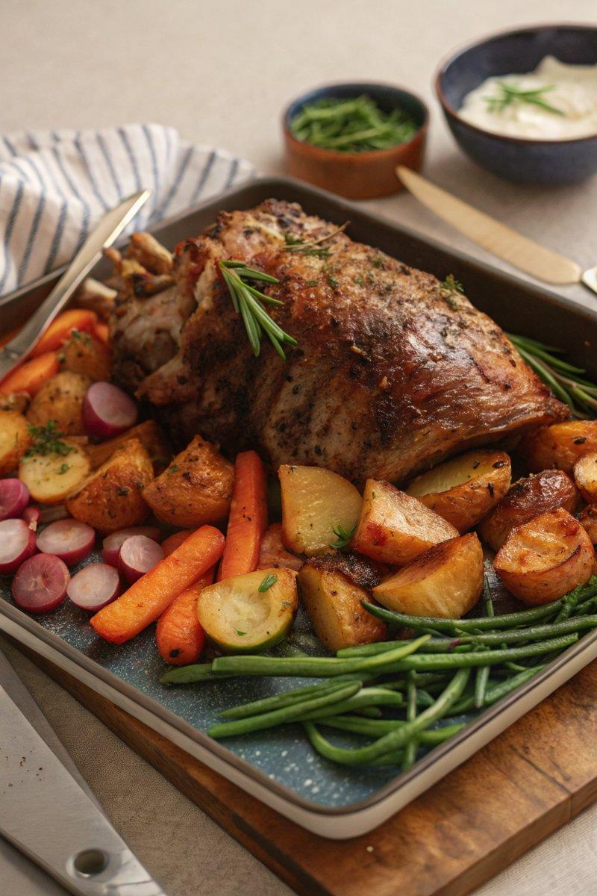

INGREDIENTS  - {'group': 'Main', 'item': '2kg leg of lamb'}  - {'group': 'Main', 'item': '4 medium potatoes, chopped into large chunks'}  - {'group': 'Main', 'item': '3 carrots, peeled and chopped'}  - {'group': 'Main', 'item': '3 parsnips, peeled and chopped'}  - {'group': 'Main', 'item': '10 large radishes, halved'}  - {'group': 'Main', 'item': '150g sliced runner beans'}  - {'group': 'Main', 'item': '100g extra-fine green beans'}  - {'group': 'Seasoning', 'item': '3 tbsp olive oil'}  - {'group': 'Seasoning', 'item': '1 tsp salt'}  - {'group': 'Seasoning', 'item': '1 tsp ground black pepper'}  - {'group': 'Seasoning', 'item': '½ tsp dried rosemary'}  - {'group': 'Seasoning', 'item': '½ tsp dried thyme'} | PREP  Preheat the oven to 180°C (350°F (175°C)). Score the fatty parts of the lamb lightly with a sharp knife. Rub 1 tbsp of olive oil into the lamb, then season with half the salt, pepper, and rosemary.  COOK  Place the lamb in a large roasting tin and roast for 1 hour 15 mins. Baste the lamb, add the potatoes around it, drizzle with remaining olive oil, and sprinkle with thyme, salt, and pepper. Roast for another 15 mins. Turn the potatoes, add carrots, parsnips, and radishes, coat in juices, and roast for 25 mins. Add runner beans and green beans, coat in juices, season with remaining salt and pepper, and roast for a final 15 mins.  PLATING  Transfer the lamb and vegetables to a warm serving platter. Serve immediately.

NOTES:
For a gravy, add 300ml lamb stock to the roasting tin juices, bring to a boil on the stovetop, and thicken with a cornflour slurry.

