SIMPLE ROAST BEEF  COOK TIME: 1 hr 30 mins  SOURCE: Unknown  #beef #British #roast | 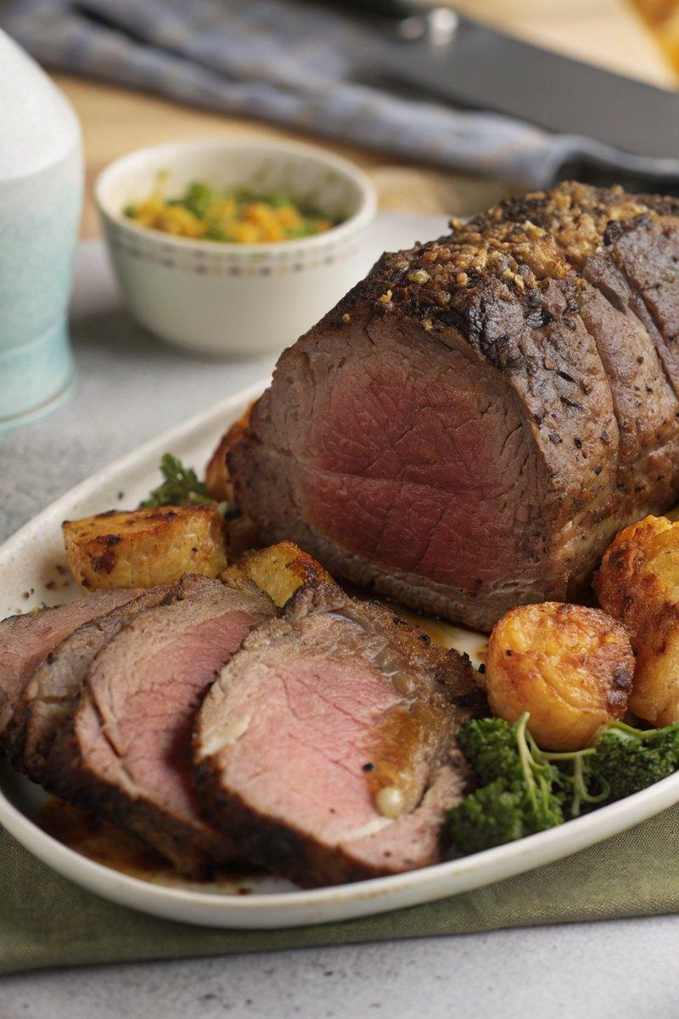

INGREDIENTS  - {'group': 'Main', 'item': '1.5kg topside of beef'}  - {'group': 'Seasoning', 'item': '1 tbsp olive oil'}  - {'group': 'Seasoning', 'item': '1/2 tsp salt'}  - {'group': 'Seasoning', 'item': '1/2 tsp ground black pepper'} | PREP  Preheat your oven to 180°C (350°F (175°C)). Drizzle the topside of beef with olive oil and season evenly with salt and ground black pepper.  COOK  Place the seasoned beef in a roasting tin and roast in the oven for 1 hour and 15 minutes for medium doneness, or 1 hour and 30 minutes for well done. Baste the beef once halfway through the cooking time to keep it moist.  PLATING  Once cooked, remove the beef from the oven and let it rest on a warm plate for 15-20 minutes. Slice thinly before serving to ensure tenderness.

NOTES:
Ensure the beef joint has a layer of fat on top to keep it juicy during roasting. Use the resting juices to make a rich gravy.

