ROAST PORK WITH CRISPY CRACKLING  COOK TIME: 2 hrs 50 mins  SOURCE: Unknown  #pork #British #roast | 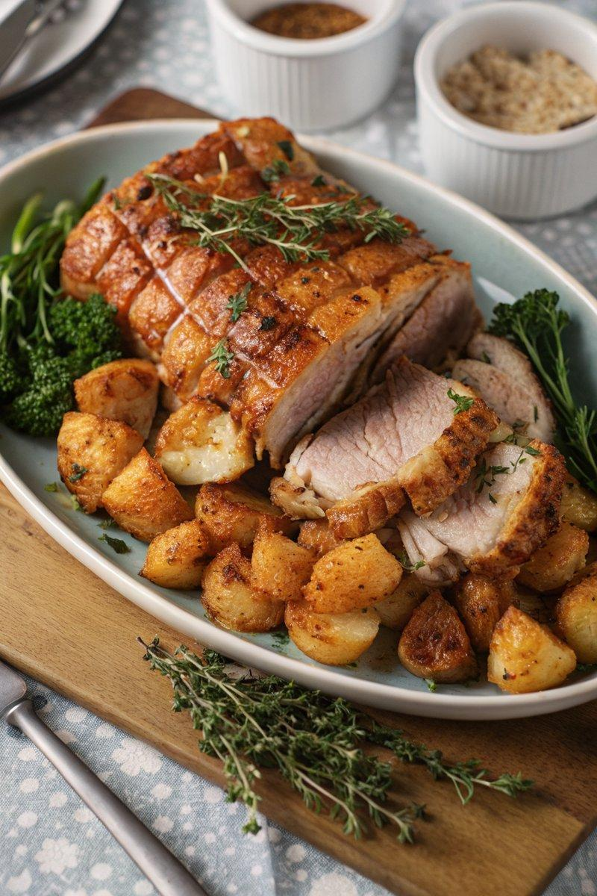

INGREDIENTS  - {'group': 'Main', 'item': '2.2-2.5kg boneless pork shoulder joint'}  - {'group': 'Seasoning', 'item': '2 garlic cloves, minced'}  - {'group': 'Seasoning', 'item': '1 tsp fresh thyme leaves or ½ tsp dried thyme'}  - {'group': 'Seasoning', 'item': '1 tbsp finely chopped flat-leaf parsley or ½ tsp dried parsley'}  - {'group': 'Seasoning', 'item': '¼ tsp ground black pepper'}  - {'group': 'Seasoning', 'item': '1 tbsp salt'}  - {'group': 'Gravy', 'item': 'Meat juices from roasted pork'}  - {'group': 'Gravy', 'item': '3 chicken stock cubes, crumbled'}  - {'group': 'Gravy', 'item': '720ml boiling water'}  - {'group': 'Gravy', 'item': '¼ tsp salt'}  - {'group': 'Gravy', 'item': '¼ tsp ground black pepper'}  - {'group': 'Gravy', 'item': '2 tbsp cornflour mixed with 5 tbsp cold water'}  - {'group': 'Gravy', 'item': '¼ tsp gravy browning (optional)'} | PREP  Preheat the oven to 170°C (340°F (171°C)). If the pork shoulder is rolled, unroll it and place it skin-side up on a tray. Score the fat in diagonal lines without cutting into the meat. Mix garlic, thyme, parsley, and black pepper, then rub this mixture onto the meat side of the pork.  COOK  Roll the pork back up, securing it with butcher's string, and rub salt all over the skin. Place the pork on a wire rack over a roasting tin and roast for 2½ hours. Increase the oven temperature to 220°C (425°F (220°C)) and roast for an additional 20-25 minutes, turning occasionally to crisp the skin. Transfer meat juices to a saucepan, add stock cubes, and boiling water. Bring to a boil, then whisk in the cornflour slurry until thickened. Add gravy browning if desired.  PLATING  Let the pork rest for 10 minutes before slicing. Add any resting juices to the gravy and reheat. Serve the pork with the gravy, apple sauce, and your choice of vegetables.

NOTES:
For the best crackling, ensure the pork skin is dry before roasting. Use a good-quality pork shoulder for optimal flavour and texture.

