SIMPLE BAKED CAULIFLOWER CHEESE  COOK TIME: 25 mins  SOURCE: Unknown  #vegetarian #British #bake | 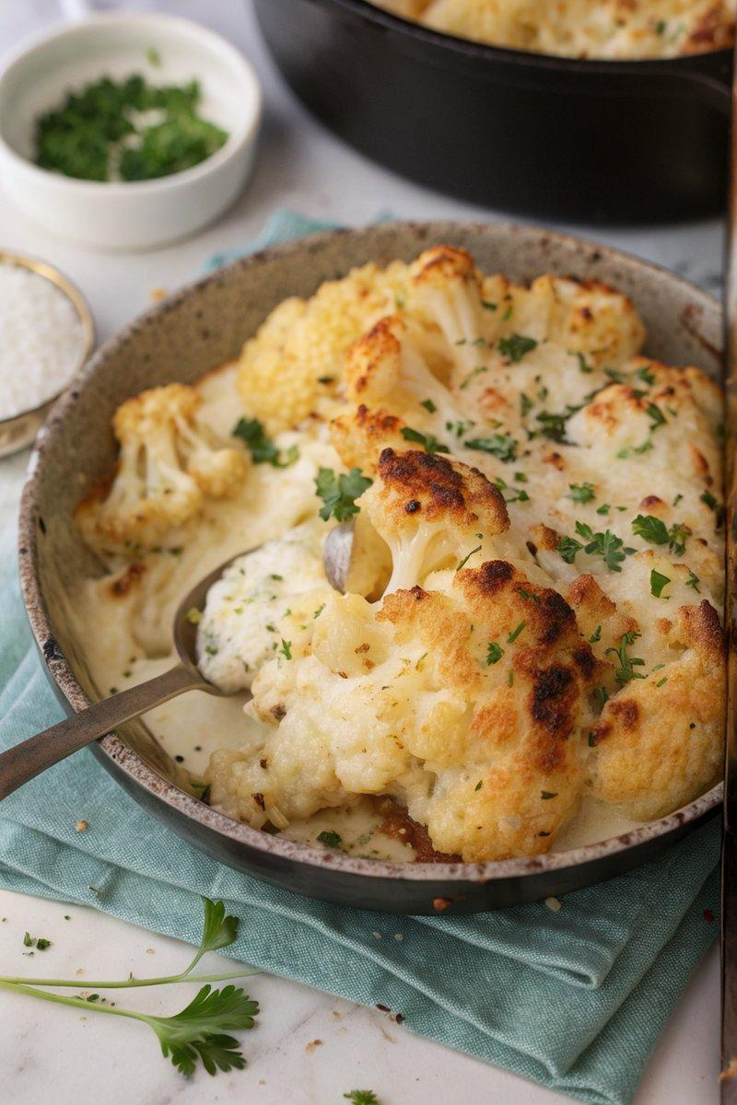

INGREDIENTS  - {'group': 'Main', 'item': '1 medium cauliflower, broken into small florets'}  - {'group': 'Main', 'item': '240ml double cream'}  - {'group': 'Main', 'item': '150g grated mature Cheddar cheese'}  - {'group': 'Seasoning', 'item': '4 tsp salt'}  - {'group': 'Seasoning', 'item': '1/2 tsp ground black pepper'}  - {'group': 'Garnish', 'item': '1 tbsp finely chopped flat-leaf parsley'} | PREP  Preheat the oven to 200°C (400°F (200°C)). Break the cauliflower into small florets.  COOK  Bring a large pan of water to a boil and simmer the cauliflower florets for 5 minutes until tender but firm. Drain well. In a baking dish, pour 2 tbsp of cream and sprinkle 2 tbsp of cheese. Layer half of the cauliflower, then add half of the remaining cream and a quarter of the remaining cheese. Season with half of the salt and pepper. Add the rest of the cauliflower, pour over the remaining cream, and sprinkle with the remaining cheese, salt, and pepper. Bake for 15-20 minutes until the cheese is golden and bubbly.  PLATING  Remove from the oven and sprinkle with chopped parsley before serving.

NOTES:
You can prepare the dish up to the baking step, refrigerate for up to a day, and bake when ready to serve.

