CRISPY ROAST POTATOES  COOK TIME: 30-35 mins  SOURCE: Unknown  #potato #British #roast | 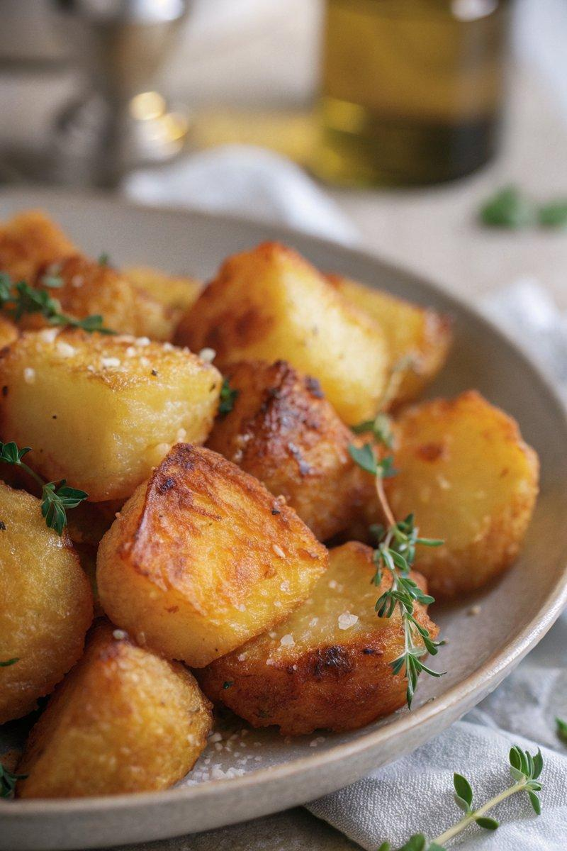

INGREDIENTS  - {'group': 'Main', 'item': '1kg floury potatoes, such as Maris Piper or Rooster'}  - {'group': 'Main', 'item': '120g lard or goose fat (or sunflower oil for vegetarian)'}  - {'group': 'Seasoning', 'item': '1 tsp Maldon salt'}  - {'group': 'Garnish', 'item': '1 tbsp thyme leaves'} | PREP  Preheat the oven to 220°C (425°F (220°C)). Peel the potatoes and cut them into chunky pieces, about 5cm (2-inch) across.  COOK  Place the potatoes in a pot, cover with cold water, and bring to a boil. Reduce heat and simmer for 10-11 minutes until the edges soften. Meanwhile, heat the lard in a roasting tin in the oven for 10 minutes. Drain the potatoes and shake them in a colander to roughen the edges. Carefully transfer them to the hot fat, turning to coat. Roast for 30-35 minutes, turning once or twice, until golden and crispy.  PLATING  Remove the potatoes from the oven and sprinkle with Maldon salt and fresh thyme leaves before serving.

NOTES:
For make-ahead preparation, par-roast the potatoes for 20 minutes, then cool and refrigerate. Reheat the fat and finish roasting for 20-30 minutes before serving.

