CREAMY DAUPHINOISE POTATOES  COOK TIME: 50 mins  SOURCE: Unknown  #potatoes #French #bake | 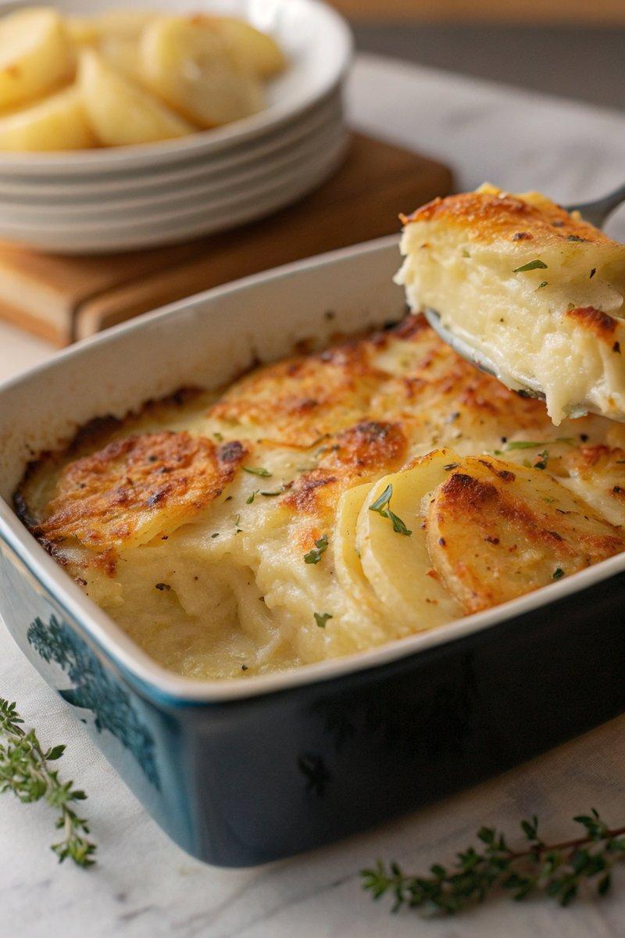

INGREDIENTS  - {'group': 'Main', 'item': '1.25kg King Edward or Maris Piper potatoes'}  - {'group': 'Sauce', 'item': '480ml double cream'}  - {'group': 'Sauce', 'item': '480ml milk'}  - {'group': 'Sauce', 'item': '3 garlic cloves, lightly crushed'}  - {'group': 'Seasoning', 'item': '½ tsp salt'}  - {'group': 'Seasoning', 'item': '½ tsp ground black pepper'}  - {'group': 'Seasoning', 'item': '¼ tsp ground white pepper'}  - {'group': 'Seasoning', 'item': 'a pinch of nutmeg'}  - {'group': 'Topping', 'item': '150g grated Gruyère cheese'}  - {'group': 'Garnish', 'item': '2 tbsp chopped flat-leaf parsley'} | PREP  Preheat the oven to 190°C (375°F (190°C)). Lightly grease a 32x18cm (13x7-inch (18cm (7-inch))) ovenproof dish. Peel and thinly slice the potatoes to about 2mm thickness using a mandolin or food processor.  COOK  In a large saucepan, combine the double cream, milk, and garlic, bringing it to a boil. Add the sliced potatoes, stirring to coat, and return to a boil. Reduce heat and simmer for 6-7 mins, stirring occasionally, until the potatoes are tender. Remove the garlic and layer half of the potatoes in the prepared dish. Sprinkle with half the seasoning and a third of the Gruyère cheese. Add the remaining potatoes and pour over enough sauce to cover. Top with the remaining seasoning and cheese.  PLATING  Bake in the oven for 40-45 mins until the cheese is golden and bubbling. Garnish with chopped parsley before serving.

NOTES:
To make ahead, bake for 20 mins, then cool and refrigerate. Reheat covered with foil at 190°C (375°F (190°C)) for 30-35 mins, removing foil for the last 15 mins.

