CLASSIC YORKSHIRE PUDDINGS  COOK TIME: 15-18 mins  SOURCE: Unknown  #vegetarian #British #bake | 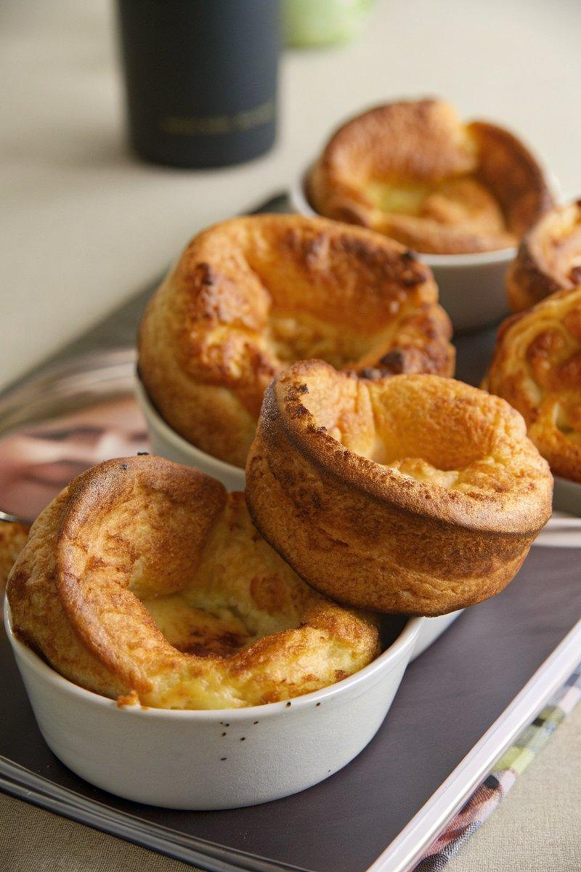

INGREDIENTS  - {'group': 'Main', 'item': '140g plain flour'}  - {'group': 'Main', 'item': '4 medium eggs'}  - {'group': 'Main', 'item': '200ml semi-skimmed milk'}  - {'group': 'Main', 'item': '6 tsp lard or beef dripping'}  - {'group': 'Seasoning', 'item': '1/4 tsp salt'}  - {'group': 'Seasoning', 'item': '1/4 tsp ground black pepper'} | PREP  In a bowl, place the flour and create a well in the center. Crack the eggs into the well and gradually whisk the flour into the eggs until combined. Slowly add the milk, whisking until the mixture is smooth with a few lumps. Chill the batter in the fridge for at least 30 minutes.  COOK  Preheat the oven to 220°C (425°F (220°C)). Add 1/2 tsp of lard to each hole of a 12-hole muffin tin and heat in the oven for 10 minutes. Season the chilled batter with salt and pepper, then whisk again. Carefully pour the batter into the hot muffin tin, filling each hole about halfway. Bake for 15-18 minutes until the puddings are risen and golden.  PLATING  Serve the Yorkshire puddings immediately while hot and crispy, alongside your favourite roast dinner.

NOTES:
For larger Yorkshire puddings, use a deep tin and bake for 25-30 minutes, turning them over for the last 5 minutes to ensure a crisp base. To make ahead, freeze the baked puddings and reheat from frozen at 200°C (400°F (200°C)) until hot and crispy.

