STEAMED VEGETABLE MEDLEY  COOK TIME: 20 mins  SOURCE: Unknown  #vegetarian #steamed #vegetables | 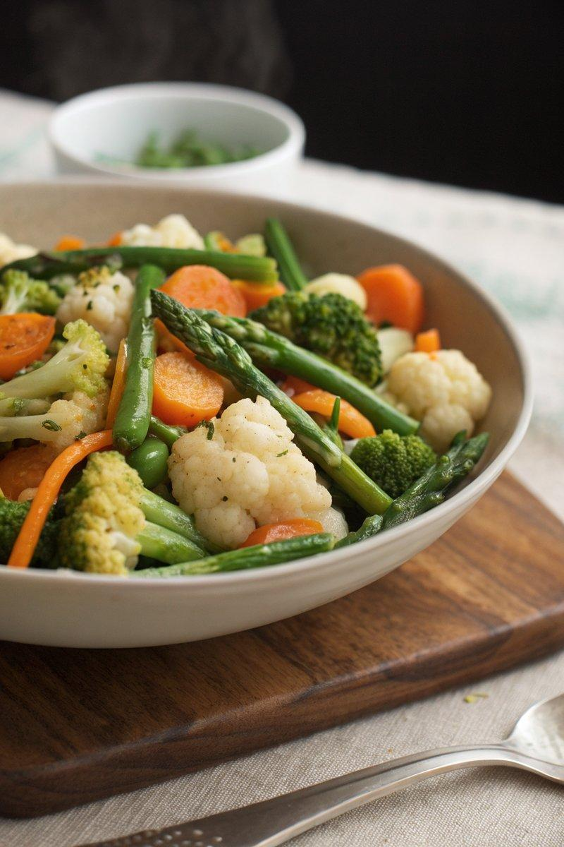

INGREDIENTS  - {'group': 'Main', 'item': '300g Chantenay carrots, scrubbed'}  - {'group': 'Main', 'item': '1 small head of cauliflower, chopped into florets'}  - {'group': 'Main', 'item': '1 head of broccoli, chopped into florets'}  - {'group': 'Main', 'item': '150g asparagus'}  - {'group': 'Main', 'item': '150g fine green beans'}  - {'group': 'Garnish', 'item': '2 tbsp salted butter, softened'}  - {'group': 'Garnish', 'item': '1/4 tsp ground white pepper'}  - {'group': 'Garnish', 'item': '1 tbsp finely chopped flat-leaf parsley'} | PREP  Scrub the Chantenay carrots and chop the cauliflower and broccoli into florets. Trim the asparagus and green beans.  COOK  Fill the base of a two-tier steamer with 5cm of water and bring to a boil. Place the carrots in the first steam basket, cover, and simmer over medium heat for 5 mins. Add the cauliflower and broccoli, steaming for another 5 mins. In the second basket, add the asparagus and green beans, placing it on top of the first basket. Steam all vegetables for an additional 5 mins until tender.  PLATING  Transfer the steamed vegetables to a warm serving bowl. Top with the softened butter and sprinkle with chopped parsley before serving.

NOTES:
Adjust the steaming times based on the size and type of vegetables used to ensure even cooking.

