GARLIC BUTTER DINNER ROLLS  COOK TIME: 18 mins  SOURCE: Unknown  #bread #American #bake | 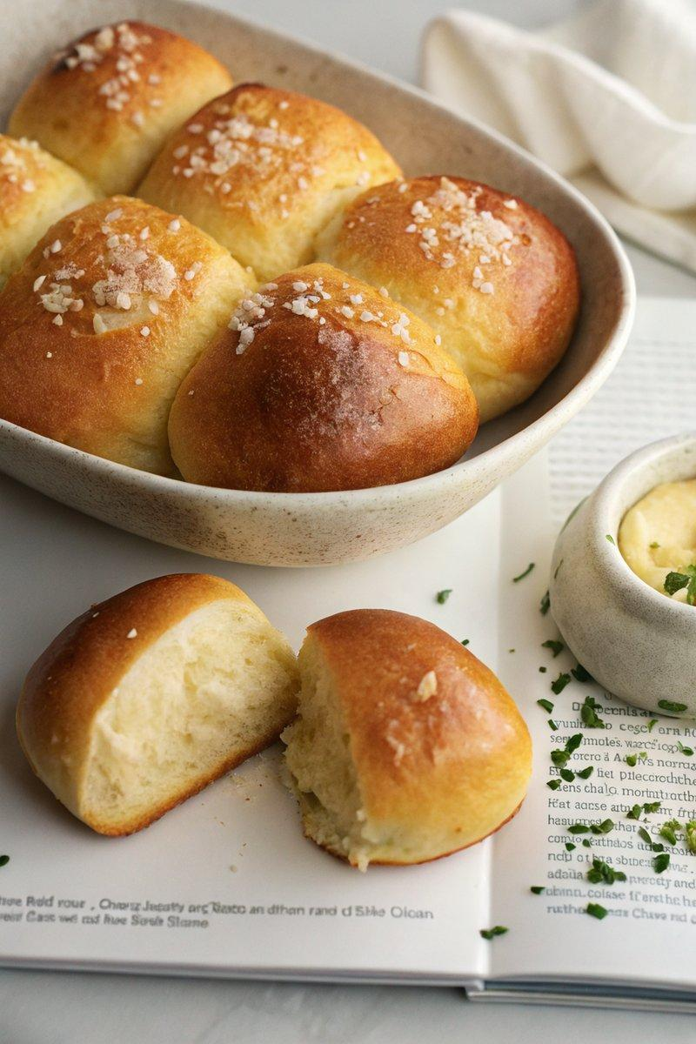

INGREDIENTS  - {'group': 'Main', 'item': '9 pieces of dough'}  - {'group': 'For Baking', 'item': '1 large egg, beaten'}  - {'group': 'Garlic Butter', 'item': '75g salted butter'}  - {'group': 'Garlic Butter', 'item': '2 cloves garlic, finely chopped'}  - {'group': 'Garnish', 'item': 'Flaky sea salt, for sprinkling'} | PREP  Lightly grease a 20-cm square baking pan. Divide the dough into 9 equal pieces. Shape each piece into a tight ball by stretching and folding the sides over into the center, then roll on the work surface until smooth.  COOK  Arrange the dough balls in the prepared pan in rows of  3. Cover with a damp towel and let proof at room temperature for 30 mins, or until doubled in size. Preheat the oven to 190°C (375°F (190°C)). Brush the tops of the proofed rolls with beaten egg. Bake for 16 to 18 mins until golden brown.  PLATING  While the rolls bake, melt the butter in a small pot over medium heat. Remove from heat and stir in the garlic. Once the rolls are out of the oven, brush them with the garlic butter and sprinkle with flaky sea salt. Serve warm.

NOTES:
No additional notes

