HOMEMADE POTATO GNOCCHI  COOK TIME: 35 mins  SOURCE: Unknown  #potato #italian #boil | 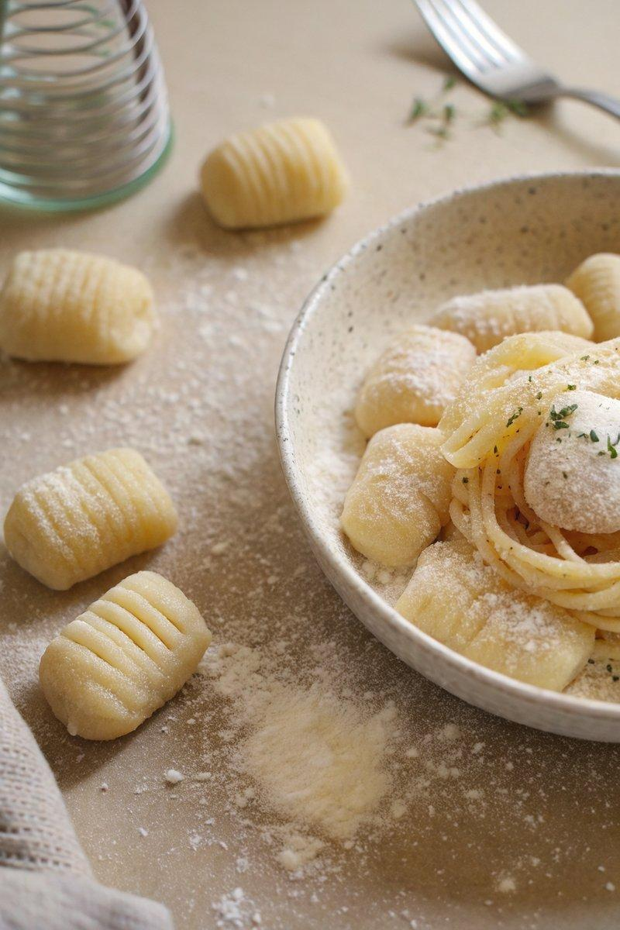

INGREDIENTS  - {'group': 'Main', 'item': '1kg russet potatoes'}  - {'group': 'Main', 'item': '1 large egg, whisked'}  - {'group': 'Main', 'item': '300g unbleached all-purpose flour, plus more for dusting'}  - {'group': 'Seasoning', 'item': '6g fine sea salt'} | PREP  Peel and boil the russet potatoes until fork-tender, about 30 minutes. Drain and let them cool slightly before discarding the skins. Pass the potatoes through a ricer or mash until smooth. Allow them to cool completely before mixing in the whisked egg.  COOK  In a bowl, combine the flour and salt. Gradually incorporate half of this mixture into the potato and egg blend. Once partially combined, add the remaining flour mixture. Knead the dough on a floured surface until smooth, about 3 minutes. Divide the dough into 5 or 6 pieces, rolling each into a 1.25cm thick cylinder. Cut into 2.5cm segments. For ridged gnocchi, roll each piece over a fork or gnocchi board. Boil in salted water until they float, then remove with a slotted spoon.  PLATING  Serve the gnocchi immediately with your choice of sauce, such as pesto or tomato sauce. Garnish with freshly grated Parmesan if desired.

NOTES:
Ensure the potatoes are completely cool before adding the egg to prevent cooking it. For best results, use a potato ricer for a smooth texture.

