CLASSIC BUTTERMILK BISCUITS  COOK TIME: 30 mins  SOURCE: Unknown  #biscuit #American #bake | 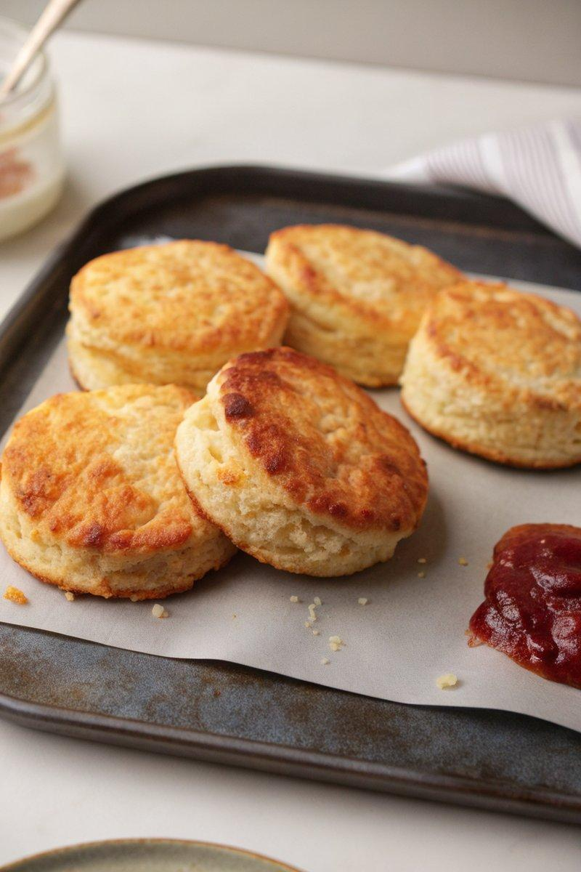

INGREDIENTS  - {'group': 'Main', 'item': '413g all-purpose flour, plus more for dusting'}  - {'group': 'Main', 'item': '26g baking powder'}  - {'group': 'Main', 'item': '6g fine sea salt'}  - {'group': 'Main', 'item': '4g granulated sugar'}  - {'group': 'Main', 'item': '149g unsalted butter, chilled'}  - {'group': 'Main', 'item': '250ml buttermilk, plus more for brushing'} | PREP  Preheat the oven to 220°C (425°F (220°C)) and line a baking sheet with parchment paper. In a food processor, combine flour, baking powder, salt, and sugar, pulsing until mixed. Cut the chilled butter into 1.25cm (10-inch) cubes and freeze briefly if needed.  COOK  Add butter to the processor and pulse until the mixture resembles pea-sized crumbs. Transfer to a bowl and gradually mix in buttermilk with a fork until a dough forms. Knead gently on an unfloured surface, then roll into a rectangle. Fold in thirds, roll out again, and fold once more. Chill for 5 mins. Roll dough to 2 cm thick, cut with a biscuit cutter, and place on the baking sheet. Brush tops with buttermilk and bake for 15-17 mins until golden.  PLATING  Serve the biscuits warm, split in half, and enjoy with butter or your favourite spread.

NOTES:
Ensure butter is very cold for the best flaky texture. You can reroll scraps to make additional biscuits.

