HOMEMADE ENGLISH MUFFINS  COOK TIME: 25 mins  SOURCE: Unknown  #bread #British #pan-fry | 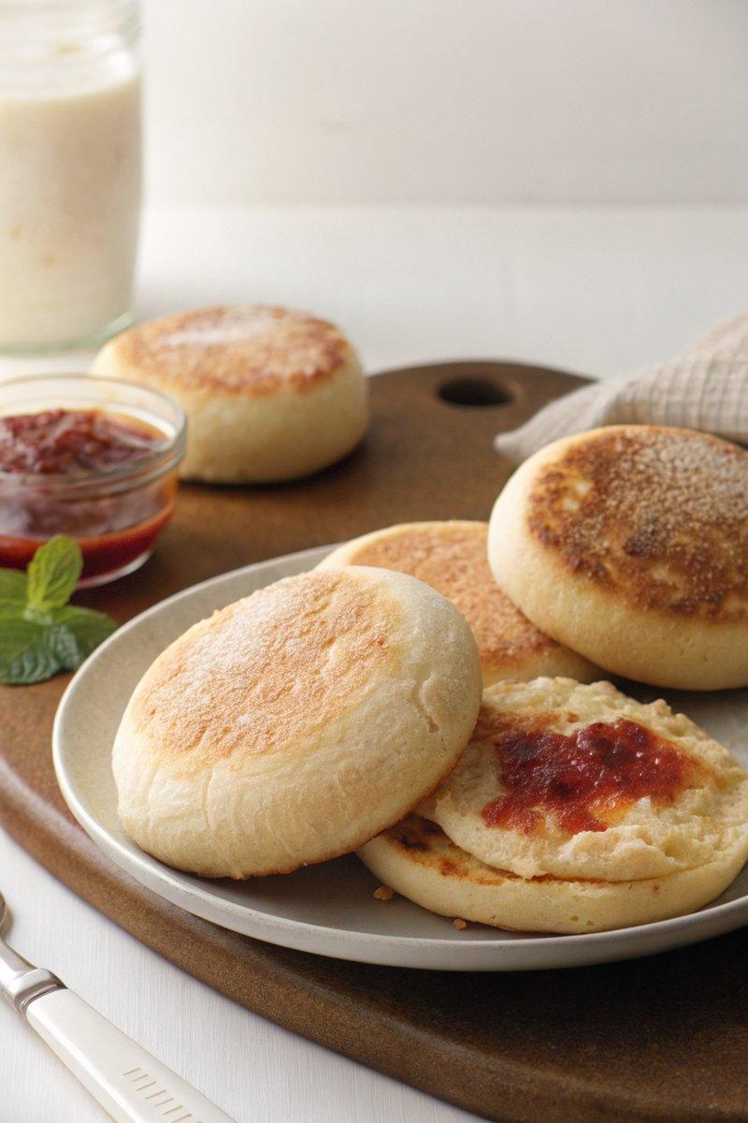

INGREDIENTS  - {'group': 'Main', 'item': '139g filtered water'}  - {'group': 'Main', 'item': '139g whole milk'}  - {'group': 'Main', 'item': '9g instant dry yeast'}  - {'group': 'Main', 'item': '600g unbleached bread flour'}  - {'group': 'Main', 'item': '6g fine sea salt'}  - {'group': 'Main', 'item': '13g granulated sugar'}  - {'group': 'Main', 'item': '28g unsalted butter, melted and cooled'}  - {'group': 'Main', 'item': 'cornmeal, for dusting'} | PREP  In a small bowl, combine the water and milk, heating to 38°C (100°F (38°C)). Stir in the yeast, cover, and let sit for 10 mins until foamy. In a medium bowl, whisk together the flour, salt, and sugar. Add the yeast mixture and melted butter, mixing by hand until a shaggy dough forms.  COOK  Knead the dough on an unfloured surface for 5-10 mins until smooth and shiny. Form into a ball, place in a greased bowl, cover with a damp towel, and let rise for 1 hour until doubled. Punch down the dough, roll out to 1.25cm thick on a floured surface, and cut into rounds using a 7.5cm cutter. Dust a baking sheet with cornmeal, place rounds on it, cover, and let rise for 30 mins to 1 hour until puffed. Preheat a lightly greased skillet over medium heat. Cook rounds for 5-7 mins per side until browned, adjusting heat as needed.  PLATING  Cool the muffins on a wire rack. Slice in half and serve warm or toasted with your choice of toppings.

NOTES:
Store in an airtight container at room temperature for up to 4 days or refrigerate for up to 1 week.

