HOMEMADE FLOUR TORTILLAS  COOK TIME: 6 mins  SOURCE: Unknown  #bread #Mexican #pan-fry | 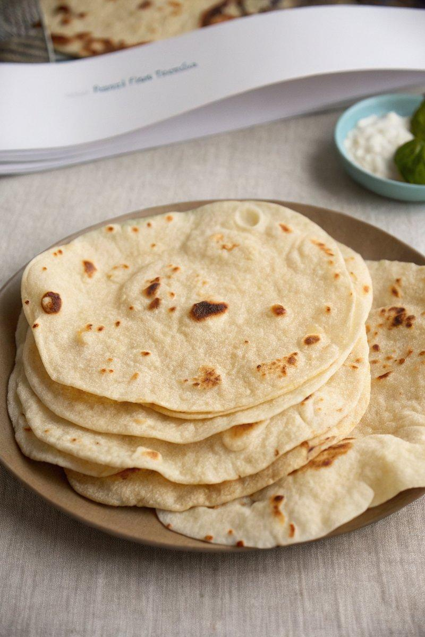

INGREDIENTS  - {'group': 'Main', 'item': '300g unbleached all-purpose flour, plus more for dusting'}  - {'group': 'Main', 'item': '6g kosher salt'}  - {'group': 'Main', 'item': '2g baking powder'}  - {'group': 'Main', 'item': '175ml warm filtered water'}  - {'group': 'Main', 'item': '60ml neutral-tasting oil'} | PREP  In a large bowl, whisk together the flour, salt, and baking powder. Gradually mix in the warm water and oil until a dough forms. Knead the dough on an unfloured surface for about 3 minutes until smooth. Cover with a damp towel and let rest for 30 minutes.  COOK  Divide the dough into 6 to 12 pieces, depending on desired tortilla size. Roll each piece into a ball, then flatten into a 25-30.5 cm circle on a lightly floured surface. Preheat a cast-iron skillet over medium-high heat. Cook each tortilla for 15 to 30 seconds per side until lightly charred.  PLATING  Keep cooked tortillas warm by placing them between a folded towel until ready to serve.

NOTES:
These tortillas are best enjoyed fresh. Adjust the size of the dough pieces based on whether you want larger burrito-sized or smaller taco-sized tortillas.

