HOMEMADE LADYFINGERS  COOK TIME: 8-12 mins  SOURCE: Unknown  #baking #Italian #dessert | 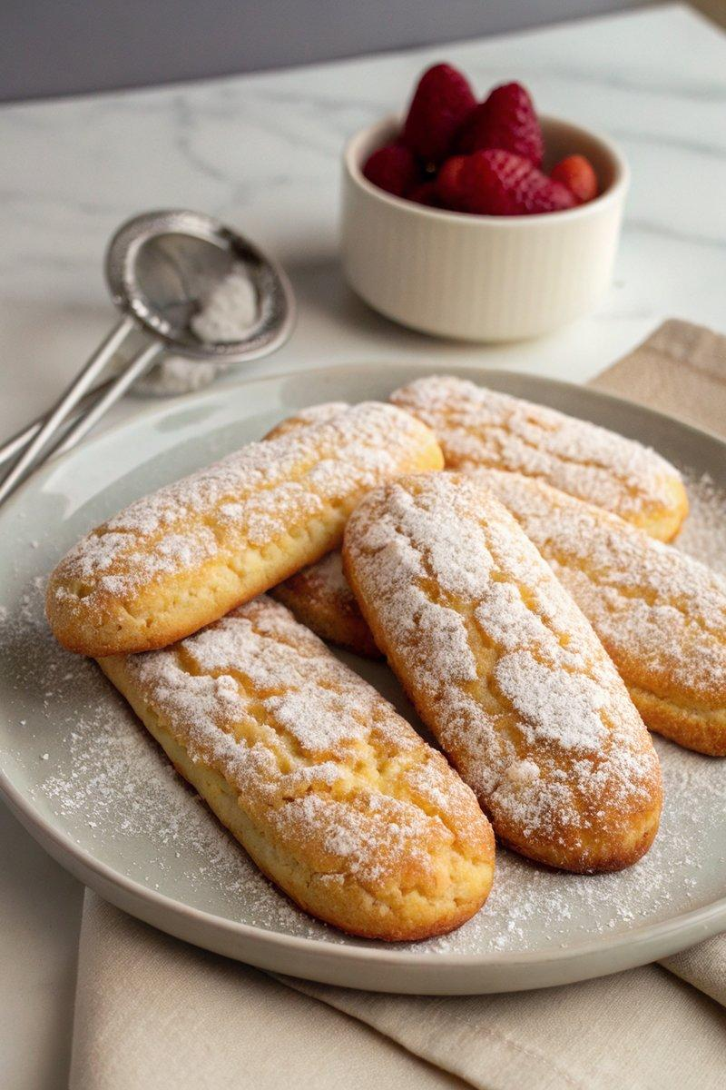

INGREDIENTS  - {'group': 'Main', 'item': '3 large eggs'}  - {'group': 'Main', 'item': '100g granulated sugar'}  - {'group': 'Main', 'item': '1 tsp pure vanilla extract'}  - {'group': 'Main', 'item': '150g unbleached all-purpose flour'}  - {'group': 'Main', 'item': 'Small pinch of fine sea salt'}  - {'group': 'Garnish', 'item': 'Powdered sugar, to dust'} | PREP  Preheat the oven to 180°C (350°F (175°C)). Line two baking sheets with parchment paper. Prepare a piping bag for the batter.  COOK  In a stand mixer bowl, combine eggs and sugar. Place over a simmering pot of water, whisking until the mixture reaches 70°C (158°F (70°C)). Attach the bowl to the mixer and beat on high until tripled in volume and soft peaks form, about 7-10 mins. Gently fold in vanilla, flour, and salt without deflating the mixture. Transfer to a piping bag and pipe 7.5cm (2-inch) long strips onto the baking sheets, leaving space between each. Dust with powdered sugar and bake for 8-12 mins until golden and crisp.  PLATING  Allow the ladyfingers to cool on a wire rack. Store in an airtight container at room temperature for up to three weeks.

NOTES:
Ensure the egg mixture does not curdle by monitoring the temperature closely. These ladyfingers are ideal for tiramisu or as a standalone treat.

