HOMEMADE GRAHAM CRACKERS  COOK TIME: 15-20 mins  SOURCE: Unknown  #baking #snack #homemade | 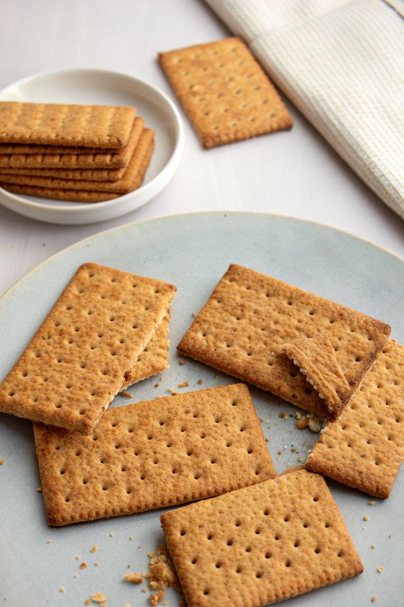

INGREDIENTS  - {'group': 'Main', 'item': '112g unbleached all-purpose flour, plus more for dusting'}  - {'group': 'Main', 'item': '211g whole wheat flour'}  - {'group': 'Main', 'item': '54g firmly packed dark brown sugar'}  - {'group': 'Main', 'item': '1 tsp fine sea salt'}  - {'group': 'Main', 'item': '1 tsp baking powder'}  - {'group': 'Main', 'item': '1½ tsp ground cinnamon'}  - {'group': 'Main', 'item': '1 large egg'}  - {'group': 'Main', 'item': '50ml whole milk, plus more if needed'}  - {'group': 'Main', 'item': '80g honey'}  - {'group': 'Main', 'item': '45ml neutral-tasting oil or extra virgin olive oil'} | PREP  In a large bowl, combine the all-purpose flour, whole wheat flour, brown sugar, sea salt, baking powder, and cinnamon. In a separate bowl, whisk together the egg, milk, honey, and oil. Gradually add the wet mixture to the dry ingredients, stirring until a dough forms. Knead the dough on an unfloured surface until smooth, adding a splash of milk if necessary.  COOK  Wrap the dough in plastic wrap and refrigerate for 30 minutes to 1 hour. Preheat the oven to 180°C (350°F (175°C)). Roll the chilled dough on a lightly floured surface to a thickness of about 3mm. Cut into desired shapes and place on a parchment-lined baking sheet. Poke holes in the dough with a fork. Bake for 15 to 20 minutes until the crackers are dry and lightly browned.  PLATING  Allow the crackers to cool completely on a wire rack, where they will become crisp. Store in an airtight container at room temperature for up to one week.

NOTES:
Ensure the dough is well-kneaded and smooth before chilling to achieve the best texture in the final crackers.

