BROWNED BUTTER-BASTED FRIED EGGS  COOK TIME: 10 mins  SOURCE: Unknown  #eggs #American #pan-fry | 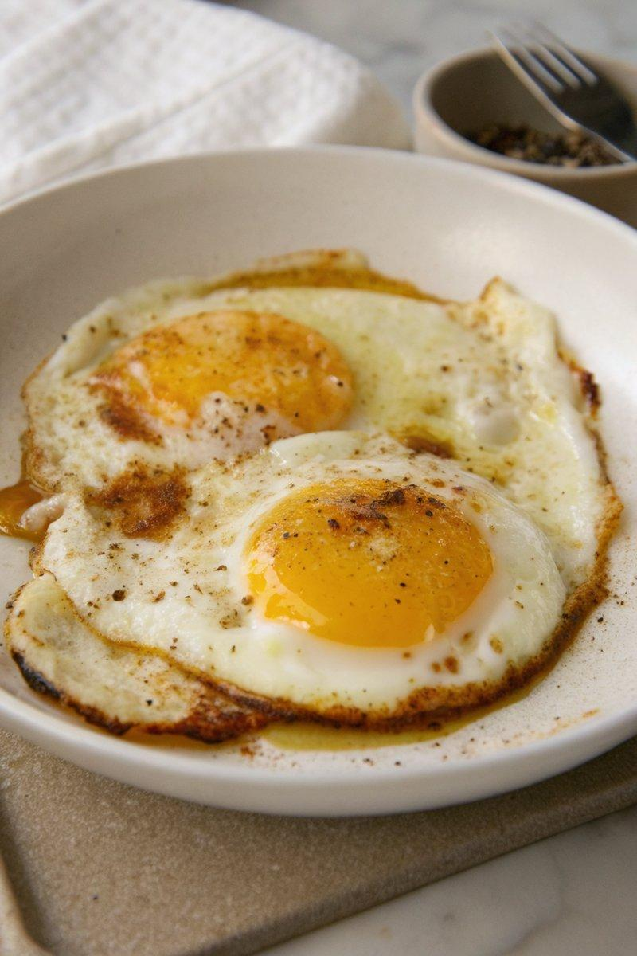

INGREDIENTS  - {'group': 'Main', 'item': '2-3 eggs'}  - {'group': 'Main', 'item': '2 tbsp neutral-tasting oil'}  - {'group': 'Main', 'item': '3 tbsp unsalted butter'}  - {'group': 'Seasoning', 'item': 'Flaky sea salt'}  - {'group': 'Seasoning', 'item': 'Freshly cracked black pepper (optional)'} | PREP  Gather all ingredients. Crack the eggs into separate small bowls to ensure easy transfer to the pan.  COOK  Heat the oil in a medium skillet over medium-high heat until shimmering. Gently slide the eggs into the pan, spacing them apart. Cook for about 1 minute until the whites are mostly set. Reduce the heat to medium and add the butter. Allow it to melt and froth, then increase the heat to medium-high. Continuously spoon the hot butter over the eggs to baste them until the tops are just set and the yolks remain runny.  PLATING  Carefully remove the eggs from the pan and place them on a serving plate. Drizzle with the browned butter from the pan. Season with flaky sea salt and freshly cracked black pepper, if desired. Serve immediately.

NOTES:
Ensure the butter is browned to a rich colour for maximum flavour. Adjust seasoning to taste.

