SCRAMBLED EGG AND BACON BREAKFAST SANDWICH  COOK TIME: 15 mins  SOURCE: Unknown  #eggs #American #sandwich | 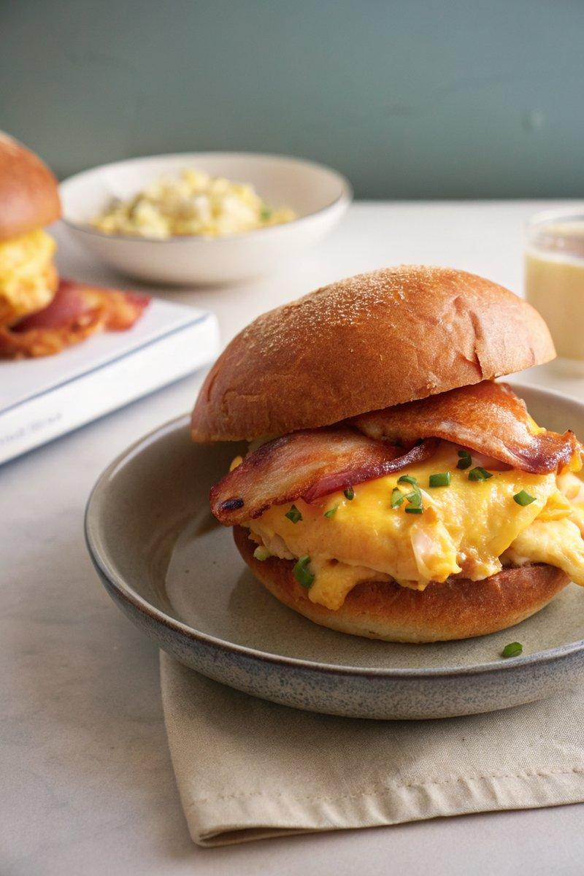

INGREDIENTS  - {'group': 'Main', 'item': '6 large eggs'}  - {'group': 'Main', 'item': '4 tbsp unsalted butter, divided'}  - {'group': 'Main', 'item': '1 tbsp crème fraiche'}  - {'group': 'Seasoning', 'item': 'Kosher salt and freshly cracked black pepper, to taste'}  - {'group': 'Garnish', 'item': 'Bunch of chives, thinly sliced'}  - {'group': 'Main', 'item': '4 sandwich buns'}  - {'group': 'Main', 'item': '8 slices cooked bacon'}  - {'group': 'Main', 'item': '8 slices cheddar or Gouda cheese'}  - {'group': 'Sauce', 'item': 'Ultra-garlicky mayo, to spread'} | PREP  Thinly slice the chives. Prepare the ultra-garlicky mayo if desired.  COOK  In a medium saucepan, bring 2.5cm of water to a gentle simmer over medium heat. Place a heatproof bowl on top, ensuring it doesn't touch the water. Crack the eggs into the bowl with 2 tbsp of butter. Whisk constantly for 8-10 mins until the eggs are creamy and starting to curd. Remove from heat and whisk in the remaining butter and crème fraiche. Season with salt and pepper, then fold in the chives.  PLATING  Toast the sandwich buns in a pan with butter until golden brown. Spread the ultra-garlicky mayo on the bottom half of each bun. Layer with 2 slices of bacon, a generous portion of scrambled eggs, and 2 slices of cheese. Broil or torch until the cheese melts. Top with the other half of the bun and serve immediately.

NOTES:
No additional notes

