CLASSIC EGGS BENEDICT WITH HOLLANDAISE SAUCE  COOK TIME: 20 mins  SOURCE: Unknown  #eggs #American #poach | 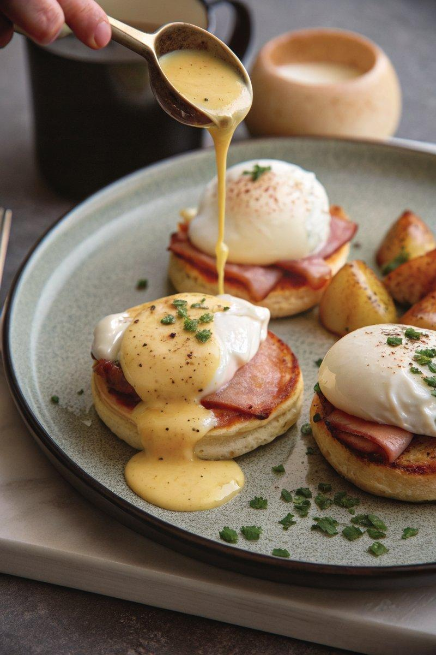

INGREDIENTS  - {'group': 'Main', 'item': '4 large eggs'}  - {'group': 'Main', 'item': '4 slices Canadian bacon'}  - {'group': 'Main', 'item': '2 English muffins, toasted'}  - {'group': 'Sauce', 'item': '½ cup salted butter'}  - {'group': 'Sauce', 'item': '3 large egg yolks'}  - {'group': 'Sauce', 'item': '1 tbsp fresh lemon juice'}  - {'group': 'Sauce', 'item': '½ tsp cayenne'}  - {'group': 'Sauce', 'item': 'Kosher salt, to taste'}  - {'group': 'Garnish', 'item': '12g very thinly sliced chives'}  - {'group': 'Garnish', 'item': 'Freshly cracked black pepper, to taste'}  - {'group': 'Garnish', 'item': 'Cayenne, optional for sprinkling'}  - {'group': 'Seasoning', 'item': 'Splash of white distilled vinegar'} | PREP  Slice the chives thinly and set aside. Toast the English muffins until golden brown.  COOK  For the hollandaise, melt the butter gently over low heat. In a blender, combine egg yolks and lemon juice, blending until thickened. Gradually add melted butter while blending until the sauce is thick and emulsified. Season with cayenne and salt, adjusting with more lemon juice if needed. Keep warm. For poached eggs, bring a saucepan of water to a gentle boil, adding vinegar. Create a whirlpool in the water and gently add each egg, cooking for 3 mins until whites are set but yolks remain runny. Remove with a slotted spoon. In a separate pan, heat olive oil and sear Canadian bacon for 2 mins per side until browned.  PLATING  Place a toasted English muffin half on each plate. Top with a slice of Canadian bacon, a poached egg, and drizzle with hollandaise sauce. Garnish with chives, black pepper, and a sprinkle of cayenne if desired.

NOTES:
No additional notes

