CINNAMON SUGAR TOAST  COOK TIME: 20 mins  SOURCE: Unknown  #bread #American #toast | 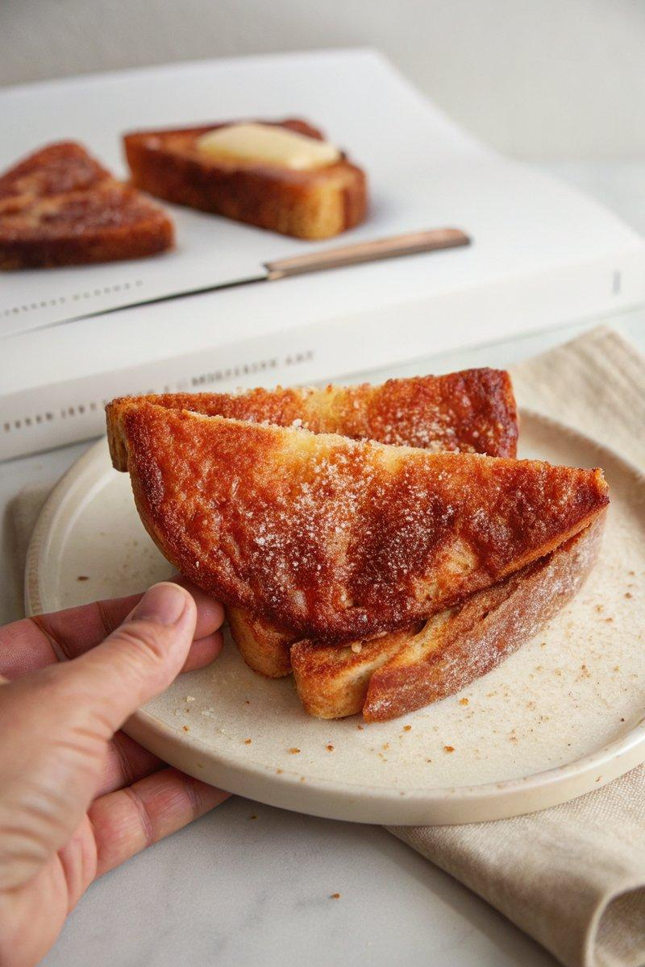

INGREDIENTS  - {'group': 'Main', 'item': '4 thick slices sandwich-style bread'}  - {'group': 'Main', 'item': '6 tbsp salted butter, softened'}  - {'group': 'Cinnamon-Sugar', 'item': '150g granulated sugar'}  - {'group': 'Cinnamon-Sugar', 'item': '108g light brown sugar'}  - {'group': 'Cinnamon-Sugar', 'item': '1½ tbsp ground cinnamon'}  - {'group': 'Cinnamon-Sugar', 'item': '¼ tsp freshly grated nutmeg (optional)'} | PREP  In a small airtight container, mix granulated sugar, brown sugar, cinnamon, and nutmeg to create the cinnamon-sugar blend.  COOK  Toast the bread slices to your preferred level of crispness. Immediately spread 1½ tbsp of softened butter on each slice while still hot. Generously sprinkle the cinnamon-sugar mixture over the buttered toast.  PLATING  Slice each toast diagonally and serve immediately while warm.

NOTES:
For a variation, consider browning the butter before spreading it on the toast or adding a dollop of whipped mascarpone on top.

