HOKKAIDO MILK BREAD CINNAMON ROLLS  COOK TIME: 25 mins  SOURCE: Unknown  #bread #Asian #baked | 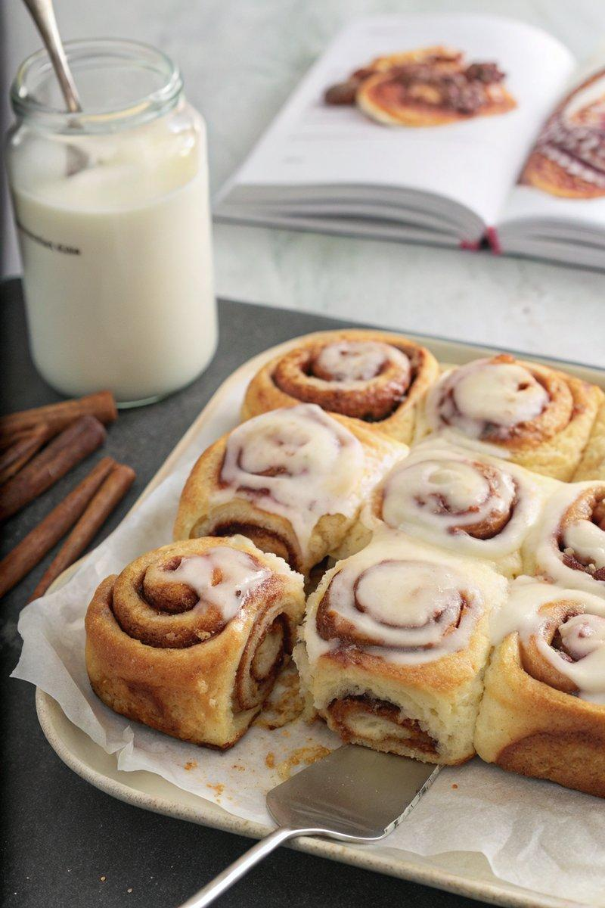

INGREDIENTS  - {'group': 'Tangzhong', 'item': '30g flour'}  - {'group': 'Tangzhong', 'item': '120ml water'}  - {'group': 'Tangzhong', 'item': '120ml milk'}  - {'group': 'Dough', 'item': '120ml milk'}  - {'group': 'Dough', 'item': '7g active dry yeast'}  - {'group': 'Dough', 'item': '400g flour'}  - {'group': 'Dough', 'item': '50g sugar'}  - {'group': 'Dough', 'item': '1 tsp salt'}  - {'group': 'Dough', 'item': '2 eggs'}  - {'group': 'Dough', 'item': '1 egg yolk'}  - {'group': 'Dough', 'item': '85g unsalted butter'}  - {'group': 'Filling', 'item': '85g unsalted butter, softened'}  - {'group': 'Filling', 'item': '100g dark brown sugar'}  - {'group': 'Filling', 'item': '2 tbsp ground cinnamon'}  - {'group': 'Glaze', 'item': '125g cream cheese, softened'}  - {'group': 'Glaze', 'item': '125g powdered sugar'}  - {'group': 'Glaze', 'item': '1 tsp pure vanilla extract'} | PREP  In a small saucepan, whisk together 30g flour, 120ml water, and 120ml milk until smooth. Heat over medium, stirring until thickened into a paste. Cool. In a small bowl, mix 120ml milk with 7g yeast, cover, and let sit for 10 mins until foamy.  COOK  In a stand mixer, combine 400g flour, 50g sugar, and 1 tsp salt. Add yeast mixture, cooled tangzhong, 2 eggs, and 1 egg yolk. Mix on medium-low for 3-5 mins until smooth. Gradually add 85g butter, mixing until incorporated. Shape dough into a ball, place in a greased bowl, cover, and let rise for 1-2 hrs until doubled. Roll dough into a 33cm (13-inch) rectangle. Spread with 85g softened butter, sprinkle with 100g brown sugar and 2 tbsp cinnamon. Roll into a log, cut into 12 pieces, and place in a greased 23x33cm (9x13-inch (33cm (13-inch))) dish. Cover and let rise for 35-45 mins. Preheat oven to 190°C (375°F (190°C)). Bake for 25 mins until golden.  PLATING  Mix 125g cream cheese, 125g powdered sugar, and 1 tsp vanilla until smooth. Spread over warm rolls before serving.

NOTES:
Ensure the tangzhong is fully cooled before adding to the dough. Rolls can be stored in an airtight container for up to 3 days.

