CLASSIC FRENCH TOAST  COOK TIME: 5-10 mins  SOURCE: Unknown  #bread #French #pan-fry | 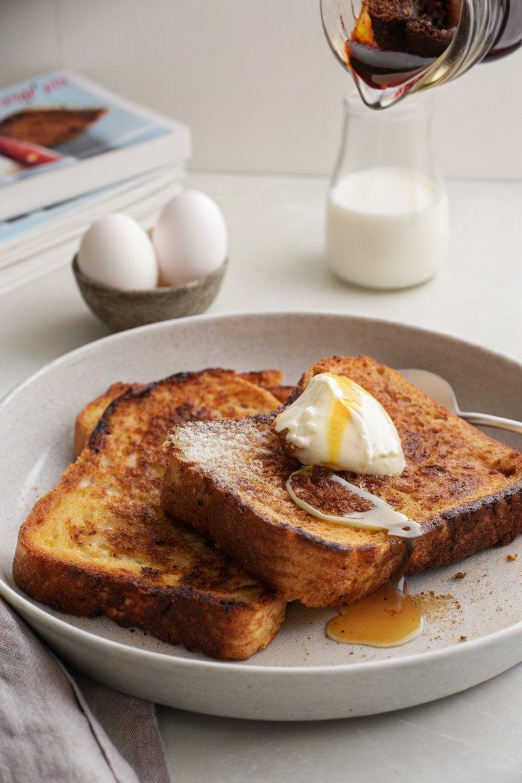

INGREDIENTS  - {'group': 'Main', 'item': '3 large eggs'}  - {'group': 'Main', 'item': '3 large egg yolks'}  - {'group': 'Seasoning', 'item': '1 tsp ground cinnamon'}  - {'group': 'Seasoning', 'item': '1/2 tsp freshly grated nutmeg'}  - {'group': 'Seasoning', 'item': '2 tbsp granulated sugar'}  - {'group': 'Seasoning', 'item': '1/2 tsp fine sea salt'}  - {'group': 'Main', 'item': '250 ml whole milk'}  - {'group': 'Main', 'item': '175 ml heavy whipping cream'}  - {'group': 'Main', 'item': '6-8 slices bread (brioche, sourdough, or challah)'}  - {'group': 'Main', 'item': '2 tbsp unsalted butter'}  - {'group': 'Topping', 'item': 'Unsalted butter'}  - {'group': 'Topping', 'item': 'Fresh whipped cream'}  - {'group': 'Topping', 'item': 'Fresh fruit'}  - {'group': 'Topping', 'item': 'High-quality pure maple syrup'}  - {'group': 'Topping', 'item': 'Powdered sugar'} | PREP  In a large shallow bowl, whisk together the eggs, egg yolks, cinnamon, nutmeg, sugar, and salt until smooth. Gradually whisk in the milk and cream until fully combined.  COOK  Heat a cast-iron skillet over medium heat and melt the butter until bubbling. Dip each slice of bread into the egg mixture, soaking for 10 to 25 seconds per side, depending on the bread's firmness. Place the soaked bread slices in the skillet and cook for 2 to 4 minutes on each side, until golden brown. Repeat with remaining slices.  PLATING  Serve the French toast warm, topped with a pat of butter, a dollop of whipped cream, fresh fruit, a drizzle of maple syrup, and a dusting of powdered sugar.

NOTES:
Adjust soaking time based on bread type; softer bread requires less time. Use high-quality maple syrup for the best flavour.

