LEMON RICOTTA PANCAKES  COOK TIME: 10 mins  SOURCE: Unknown  #pancakes #American #pan-fry | 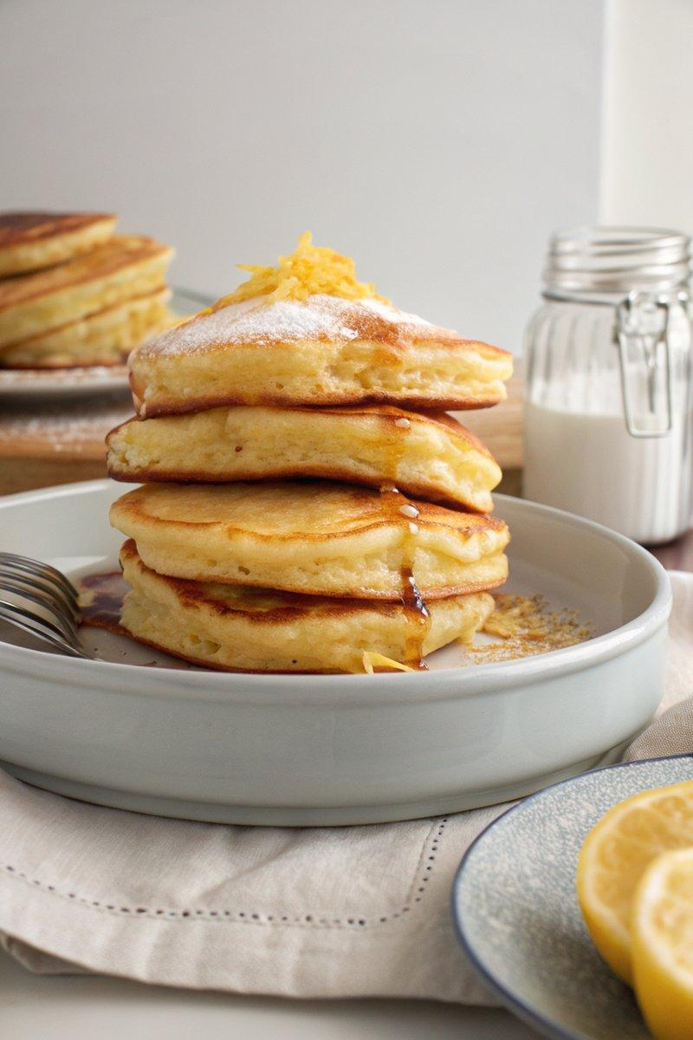

INGREDIENTS  - {'group': 'Main', 'item': '225g unbleached all-purpose flour'}  - {'group': 'Main', 'item': '7g baking powder'}  - {'group': 'Main', 'item': '1g baking soda'}  - {'group': 'Main', 'item': '26g granulated sugar'}  - {'group': 'Main', 'item': '2g fine sea salt'}  - {'group': 'Main', 'item': 'Zest of 1 lemon'}  - {'group': 'Main', 'item': '2 large eggs'}  - {'group': 'Main', 'item': '250ml whole milk'}  - {'group': 'Main', 'item': '15ml neutral tasting oil'}  - {'group': 'Main', 'item': '220g ricotta'}  - {'group': 'For Cooking', 'item': 'Unsalted butter or cooking spray'} | PREP  In a medium bowl, combine the flour, baking powder, baking soda, sugar, salt, and lemon zest. In another bowl, whisk the eggs, then add milk, oil, and ricotta, mixing until smooth.  COOK  Combine the wet and dry ingredients, stirring until just mixed with a few lumps remaining. Let the batter rest for 5 minutes. Heat a nonstick skillet over medium heat and lightly grease with butter or spray. Pour batter into the skillet in desired portions, cooking each pancake for 2-3 minutes per side until golden brown and cooked through.  PLATING  Serve the pancakes warm with your choice of toppings such as salted butter, maple syrup, jam, or fresh fruit.

NOTES:
Resting the batter allows the ingredients to meld, enhancing the pancakes' texture.

