SMASHED POTATOES WITH SPICY TOMATO SAUCE  COOK TIME: 45 mins  SOURCE: Unknown  #potato #Spanish #roast | 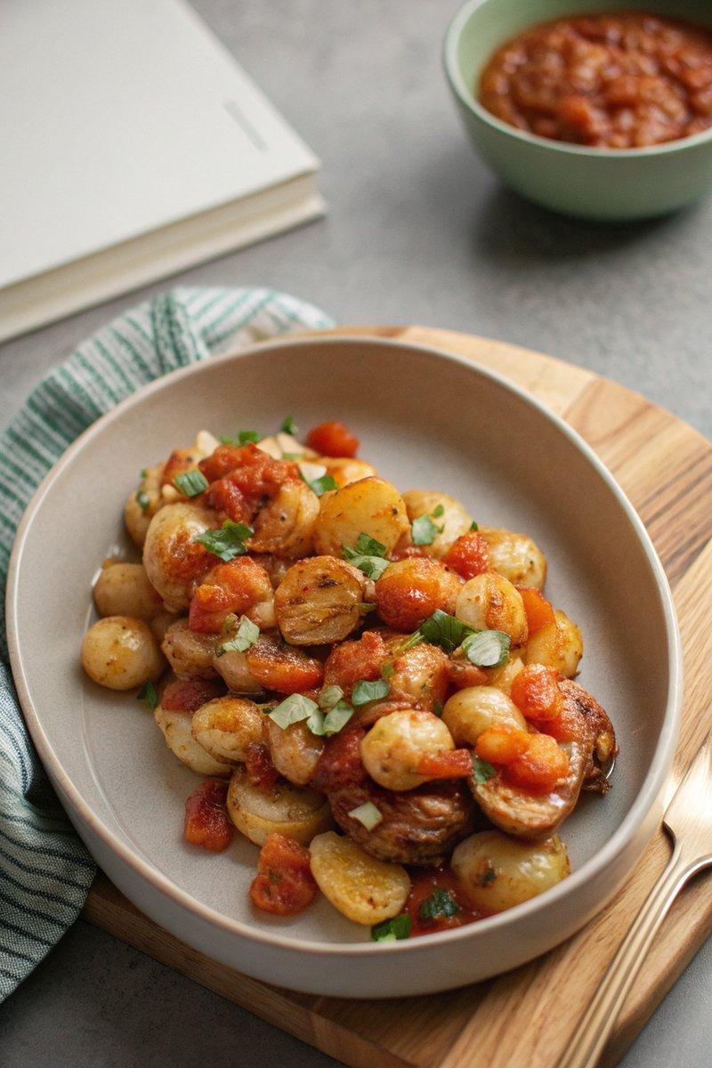

INGREDIENTS  - {'group': 'Main', 'item': '450g baby potatoes'}  - {'group': 'Main', 'item': '2 tbsp extra virgin olive oil'}  - {'group': 'Main', 'item': 'Kosher salt, to taste'}  - {'group': 'Sauce', 'item': '3 tbsp extra virgin olive oil'}  - {'group': 'Sauce', 'item': '1 medium sweet onion, diced'}  - {'group': 'Sauce', 'item': '4 cloves garlic, roughly chopped'}  - {'group': 'Sauce', 'item': '1 can (400g) crushed tomatoes, undrained'}  - {'group': 'Sauce', 'item': '1 tbsp smoked paprika'}  - {'group': 'Sauce', 'item': '2 tsp sweet paprika'}  - {'group': 'Sauce', 'item': '1 tsp granulated sugar'}  - {'group': 'Garnish', 'item': 'Cilantro leaves, optional'}  - {'group': 'For Serving', 'item': 'Mayonnaise, optional'} | PREP  Boil the baby potatoes until they are soft and can be easily pierced with a fork. Drain and let them dry until the skins are no longer wet. Preheat the oven to 220°C (425°F (220°C)).  COOK  While the potatoes are boiling, prepare the bravas sauce. Heat 3 tbsp of olive oil in a saucepan over medium heat. Add the diced onion, season with salt, smoked paprika, and sweet paprika, and cook until the onion softens. Add the garlic and cook until fragrant. Stir in the crushed tomatoes and sugar, then simmer for about 15 minutes until the sauce reduces by 25%. Taste and adjust seasoning if needed. Optionally, blend the sauce for a smooth consistency. Place the dried potatoes on a foil-lined baking sheet. Use a flat cup to gently smash them until craggy but intact. Drizzle with olive oil, season with salt, and roast for about 25 minutes until crispy and golden.  PLATING  Serve the crispy potatoes with the bravas sauce and mayonnaise. For a decorative touch, use squirt bottles to dot the potatoes with alternating spots of sauce and mayonnaise. Garnish with cilantro leaves if desired.

NOTES:
For an extra kick, add grated garlic to the mayonnaise. This dish is best served fresh to maintain the crispiness of the potatoes.

