BEER-BATTERED COD WITH SAUCE GRIBICHE  COOK TIME: 20 mins  SOURCE: Unknown  #fish #French #deep-fry | 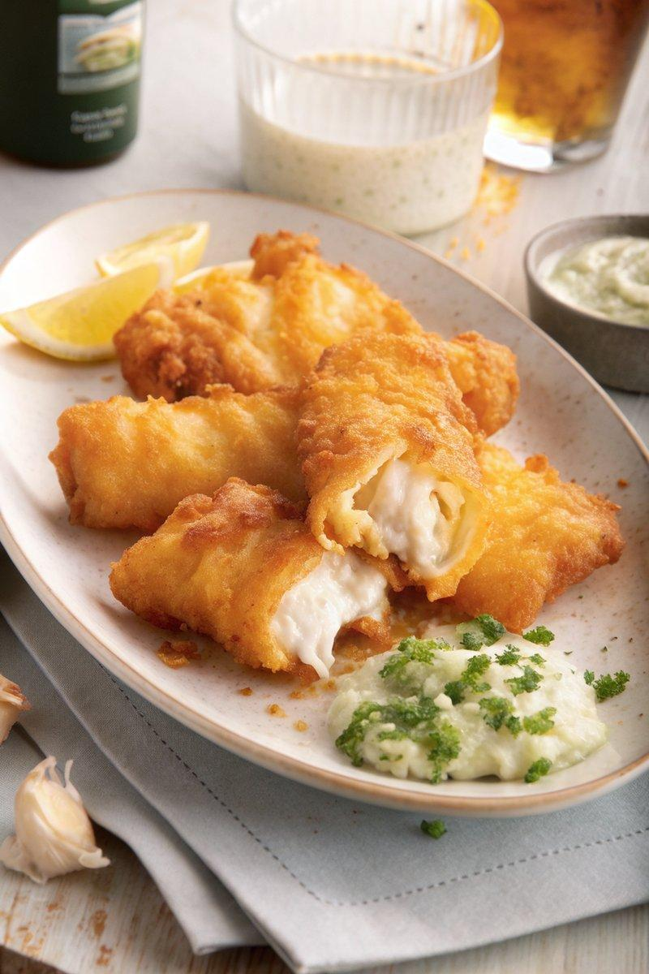

INGREDIENTS  - {'group': 'Main', 'item': '1kg cod, cut into 5x2 cm pieces'}  - {'group': 'Main', 'item': '225g unbleached all-purpose flour, divided'}  - {'group': 'Main', 'item': '7g paprika'}  - {'group': 'Main', 'item': '1 tsp garlic powder'}  - {'group': 'Main', 'item': '2 tsp white pepper'}  - {'group': 'Main', 'item': '15g fine sea salt, plus more to season'}  - {'group': 'Main', 'item': '1 large egg'}  - {'group': 'Main', 'item': '240ml light beer'}  - {'group': 'Main', 'item': 'High heat oil, such as canola or vegetable, for frying'}  - {'group': 'For Serving', 'item': 'Sauce gribiche'} | PREP  Season the cod pieces generously with sea salt and let them rest on paper towels at room temperature for 15 minutes to draw out moisture. Meanwhile, prepare the batter by mixing 60g of flour in a small bowl. In a separate medium bowl, combine the remaining 120g of flour with paprika, garlic powder, white pepper, and salt. Gradually whisk in the beer until a smooth batter forms.  COOK  Heat oil in a large, deep cast-iron skillet or heavy-bottomed pot to 185°C (365°F (185°C)), using a fry thermometer to maintain the temperature. Dredge the cod pieces in the reserved flour, shaking off excess, then dip them into the beer batter. Fry the fish in batches, ensuring not to overcrowd the skillet, for 3 to 5 minutes, flipping once, until golden brown and crispy. Remove with a kitchen spider or tongs and drain on a wire rack.  PLATING  Serve the crispy beer-battered cod immediately with sauce gribiche on the side.

NOTES:
Ensure the oil temperature remains consistent for even frying. Serve with French fries or a green salad for a complete meal.

