GRILLED BRANZINO WITH COCONUT BROTH  COOK TIME: 15 mins  SOURCE: Unknown  #fish #Asian #grill | 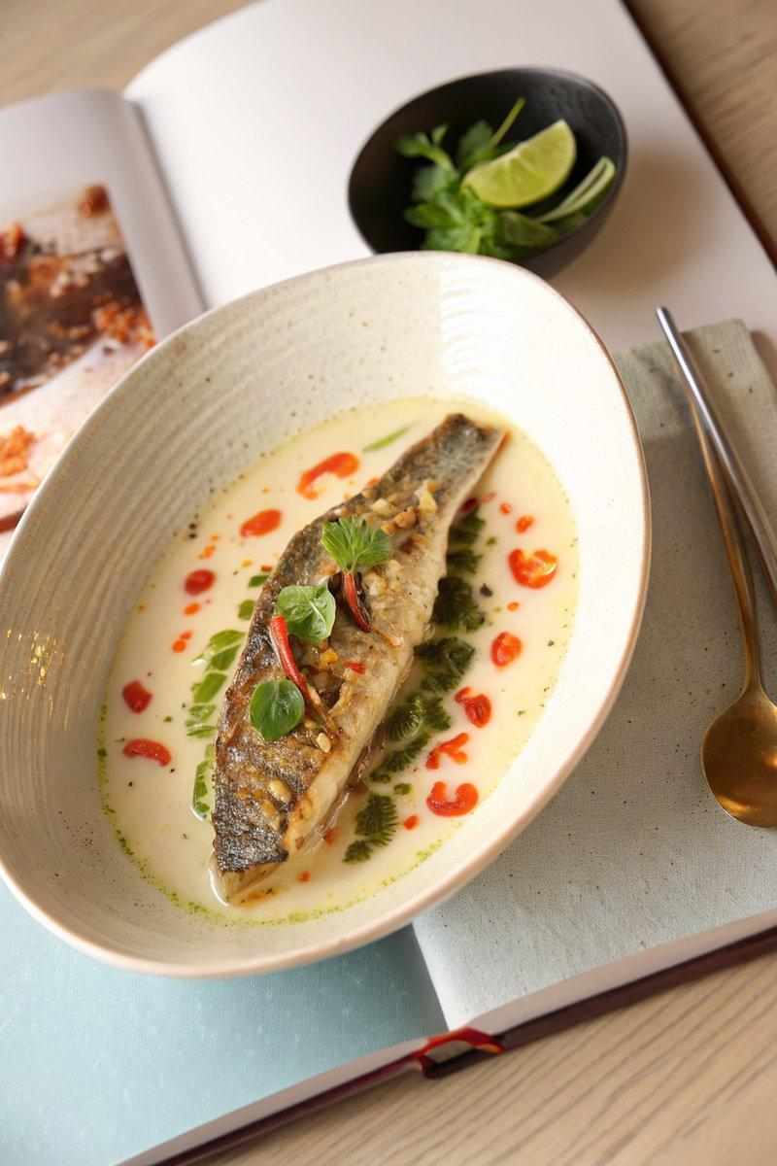

INGREDIENTS  - {'group': 'Main', 'item': '4 branzino fillets'}  - {'group': 'Coconut Broth', 'item': '400ml coconut milk'}  - {'group': 'Coconut Broth', 'item': '1 stalk lemongrass, chopped'}  - {'group': 'Coconut Broth', 'item': '2 slices galangal'}  - {'group': 'Coconut Broth', 'item': '2 tbsp fish sauce'}  - {'group': 'Coconut Broth', 'item': '1 tbsp palm sugar'}  - {'group': 'Herb Mixture', 'item': '2 tbsp basil, chopped'}  - {'group': 'Herb Mixture', 'item': '2 tbsp mint, chopped'}  - {'group': 'Herb Mixture', 'item': '2 tbsp green onion, sliced'}  - {'group': 'Herb Mixture', 'item': '2 tbsp pickled red onions'}  - {'group': 'Garnish', 'item': 'Chili oil, for drizzling'}  - {'group': 'Garnish', 'item': 'Lime wedges, for serving'} | PREP  In a medium saucepan, combine coconut milk, lemongrass, and galangal. Heat over medium until steamy, then cover and steep for 12 mins. Strain and whisk in fish sauce and palm sugar. Season with salt. In a small bowl, mix cilantro, basil, mint, green onion, and pickled red onions. Cover and refrigerate.  COOK  Preheat grill to medium-high, leaving one side off. Spray a wire rack with cooking spray. Pat branzino fillets dry, spray skin with cooking spray, and season with salt. Place fillets skin-side down on the rack. Grill over hot side for ~3 mins until skin is crisp and fish is halfway cooked. Flip and cook for another 30-60 secs until just cooked through. If needed, move to cooler side to prevent overcooking.  PLATING  Pour ~1.25cm of hot coconut broth into shallow bowls. Place fish flesh-side down in broth. Top with herb mixture and sprinkle with flaky salt. Drizzle with chili oil and serve with lime wedges.

NOTES:
Ensure the grill is well-preheated to prevent sticking. Adjust seasoning of the broth to taste before serving.

