PARMESAN AND NUT CRUSTED SALMON  COOK TIME: 10-15 mins  SOURCE: Unknown  #salmon #American #bake | 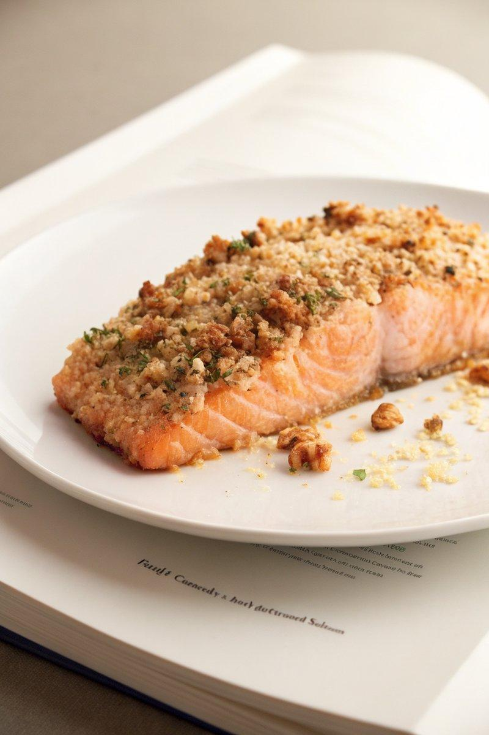

INGREDIENTS  - {'group': 'Main', 'item': '4 salmon fillets'}  - {'group': 'Sauce', 'item': '60ml mayonnaise'}  - {'group': 'Sauce', 'item': '2 tbsp mustard'}  - {'group': 'Sauce', 'item': '2 cloves garlic, minced'}  - {'group': 'Crust', 'item': '60g walnuts'}  - {'group': 'Crust', 'item': '60g pecans'}  - {'group': 'Crust', 'item': '60g freshly grated Parmesan cheese'}  - {'group': 'Crust', 'item': '2 tbsp chopped fresh parsley'}  - {'group': 'Seasoning', 'item': 'Salt and freshly cracked black pepper, to taste'}  - {'group': 'For Serving', 'item': 'Lemon wedges'} | PREP  Preheat the oven to 220°C (425°F (220°C)) and line a baking sheet with parchment paper. Arrange the salmon fillets on the sheet. In a small bowl, combine mayonnaise, mustard, garlic, and salt. In a resealable bag, crush walnuts and pecans into small pieces, then mix with Parmesan, parsley, salt, and pepper in a bowl.  COOK  Season the salmon fillets with salt and pepper. Brush each fillet generously with the mayonnaise mixture. Press the nut and cheese mixture onto the top of each fillet, ensuring an even coating. Bake in the preheated oven for 10 to 15 minutes, until the salmon is cooked through and the crust is golden.  PLATING  Serve the salmon fillets hot, garnished with lemon wedges for squeezing over the top.

NOTES:
For an extra touch of luxury, add a few tablespoons of grated black truffle to the mayonnaise mixture if desired.

