MAINE-STYLE LOBSTER ROLLS  COOK TIME: 5 mins  SOURCE: Unknown  #lobster #American #pan-fry | 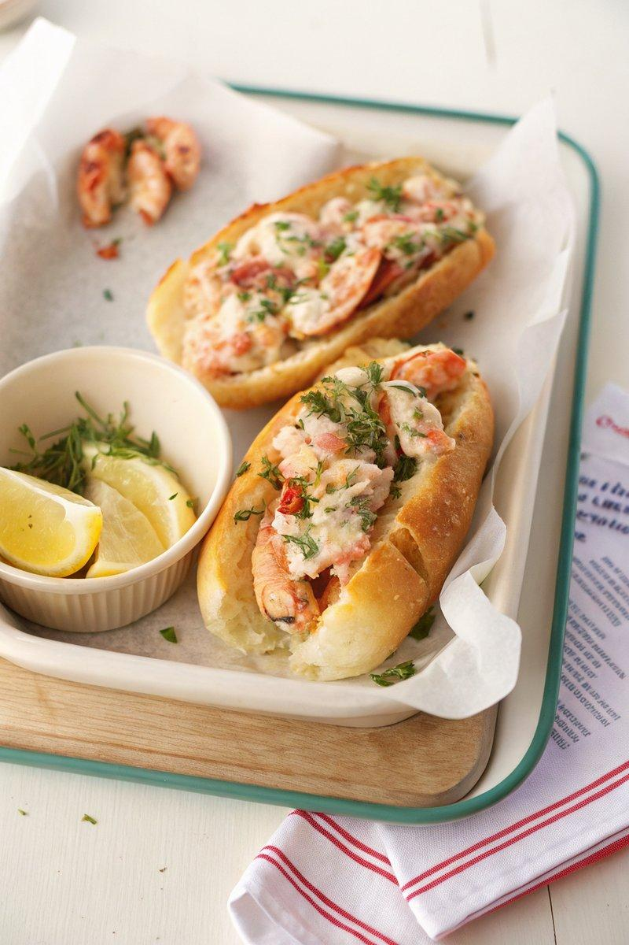

INGREDIENTS  - {'group': 'Main', 'item': '2 large lobsters, steamed and chilled'}  - {'group': 'Sauce', 'item': '77g mayonnaise'}  - {'group': 'Sauce', 'item': 'Zest and juice of 1 lemon'}  - {'group': 'Sauce', 'item': '1 tbsp finely sliced chives'}  - {'group': 'Sauce', 'item': '1 tbsp finely chopped dill'}  - {'group': 'Sauce', 'item': '1 tbsp finely chopped tarragon'}  - {'group': 'Seasoning', 'item': 'Kosher salt and freshly cracked black pepper'}  - {'group': 'Main', 'item': '4 hot dog buns'}  - {'group': 'Main', 'item': '4 tbsp unsalted butter, softened'}  - {'group': 'Garnish', 'item': 'Additional chives and lemon zest'} | PREP  Crack the lobster shells and remove the meat, keeping it as whole as possible. Set aside on a paper towel to drain. In a medium bowl, whisk together mayonnaise, lemon zest and juice, chives, dill, tarragon, salt, and pepper.  COOK  Cut the lobster into large bite-sized pieces if desired, then add to the mayonnaise mixture and toss to coat evenly. Split the buns with a sharp knife and spread softened butter inside. Place them butter-side down in a cold nonstick pan over medium heat. Toast for about 2 minutes until golden brown.  PLATING  Stuff the toasted buns with the lobster salad. Garnish with additional chives, lemon zest, and a sprinkle of black pepper before serving.

NOTES:
For humane preparation, consider dispatching live lobsters with a knife before steaming. Look for online tutorials for proper technique.

