DANISH GRAVLAX OPEN-FACED SANDWICH  COOK TIME: 5 mins  SOURCE: Unknown  #salmon #Danish #sandwich | 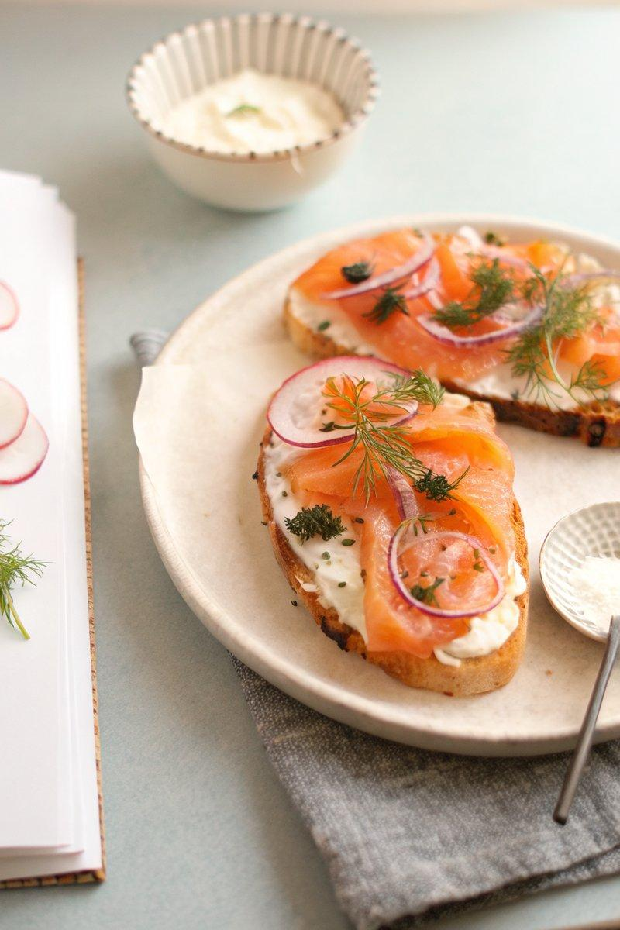

INGREDIENTS  - {'group': 'Main', 'item': '8 slices sourdough bread'}  - {'group': 'Main', 'item': '200g gravlax, thinly sliced'}  - {'group': 'Sauce', 'item': '120ml crème fraiche'}  - {'group': 'Sauce', 'item': '1 lemon, zested and juiced'}  - {'group': 'Sauce', 'item': '2 tbsp horseradish, grated'}  - {'group': 'Sauce', 'item': '1 clove garlic, minced'}  - {'group': 'Sauce', 'item': '2 tbsp chives, finely chopped'}  - {'group': 'Garnish', 'item': '1 shallot, thinly sliced'}  - {'group': 'Garnish', 'item': 'Fresh dill, for garnish'}  - {'group': 'Garnish', 'item': 'Salt and freshly cracked black pepper, to taste'} | PREP  In a medium bowl, whisk together the crème fraiche, lemon zest and juice, horseradish, garlic, and chives until well combined. Season with salt and pepper to taste. Thinly slice the radishes and shallots, and set aside.  COOK  Toast the sourdough bread slices until golden brown. You can use a toaster or toast them in a pan with butter for extra flavour. Allow the toast to cool slightly.  PLATING  Spread a generous layer of the horseradish-chive cream on each slice of toast. Top with 2-3 slices of gravlax. Arrange the radish slices and shallot rings on top, and garnish with fresh dill. Serve immediately.

NOTES:
For an extra touch of luxury, add a small spoonful of caviar on top of each sandwich.

