PAN-SEARED RIBEYE STEAK WITH THYME AND GARLIC  COOK TIME: 8 mins  SOURCE: Unknown  #beef #American #pan-fry | 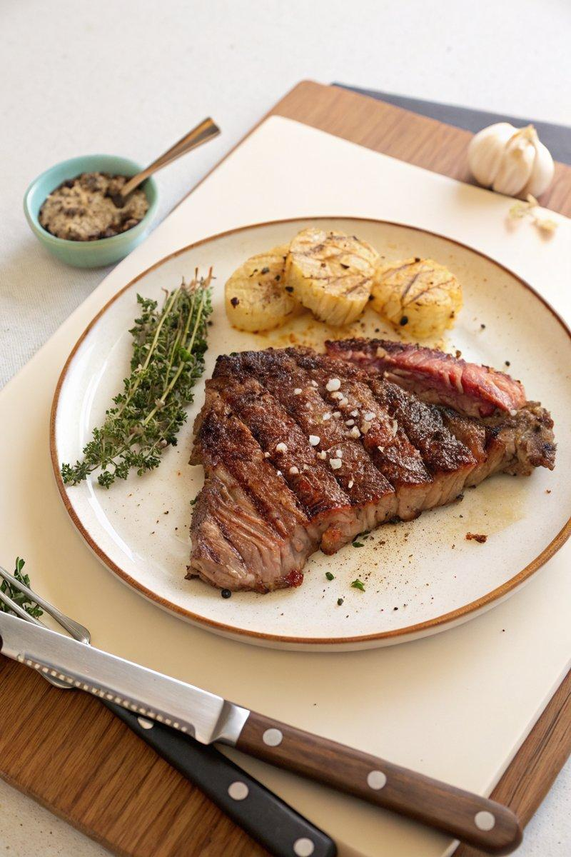

INGREDIENTS  - {'group': 'Main', 'item': '2 ribeye steaks, 3-3.75cm thick'}  - {'group': 'Seasoning', 'item': 'Kosher salt, to taste'}  - {'group': 'Seasoning', 'item': 'Freshly cracked black pepper, to taste'}  - {'group': 'Cooking', 'item': '2 tbsp neutral oil'}  - {'group': 'Basting', 'item': '4 tbsp unsalted butter'}  - {'group': 'Basting', 'item': '1 bunch thyme'}  - {'group': 'Basting', 'item': '3 cloves garlic, skin on and lightly crushed'} | PREP  Pat the ribeye steaks completely dry with paper towels. Generously season both sides with kosher salt and freshly cracked black pepper.  COOK  Preheat a medium skillet over medium-high heat. Add the neutral oil and heat until it is extremely hot and nearly smoking. Carefully place the steaks in the skillet, ensuring at least 2.5cm (2-inch) of space between them. Sear for 2-3 mins on each side until a deep brown crust forms. Add the unsalted butter, thyme, and crushed garlic to the skillet. Baste the steaks continuously with the melted butter and aromatics until they reach an internal temperature of 56°C (133°F (56°C)) for medium-rare.  PLATING  Remove the steaks from the skillet and let them rest uncovered for 5 mins before slicing. Serve immediately with your choice of sides.

NOTES:
For best results, ensure the skillet is very hot before adding the steaks to achieve a perfect sear. Adjust cooking time based on steak thickness and desired doneness.

