MOJO-BRAISED PULLED PORK  COOK TIME: 3 hrs  SOURCE: Unknown  #pork #Cuban #braise | 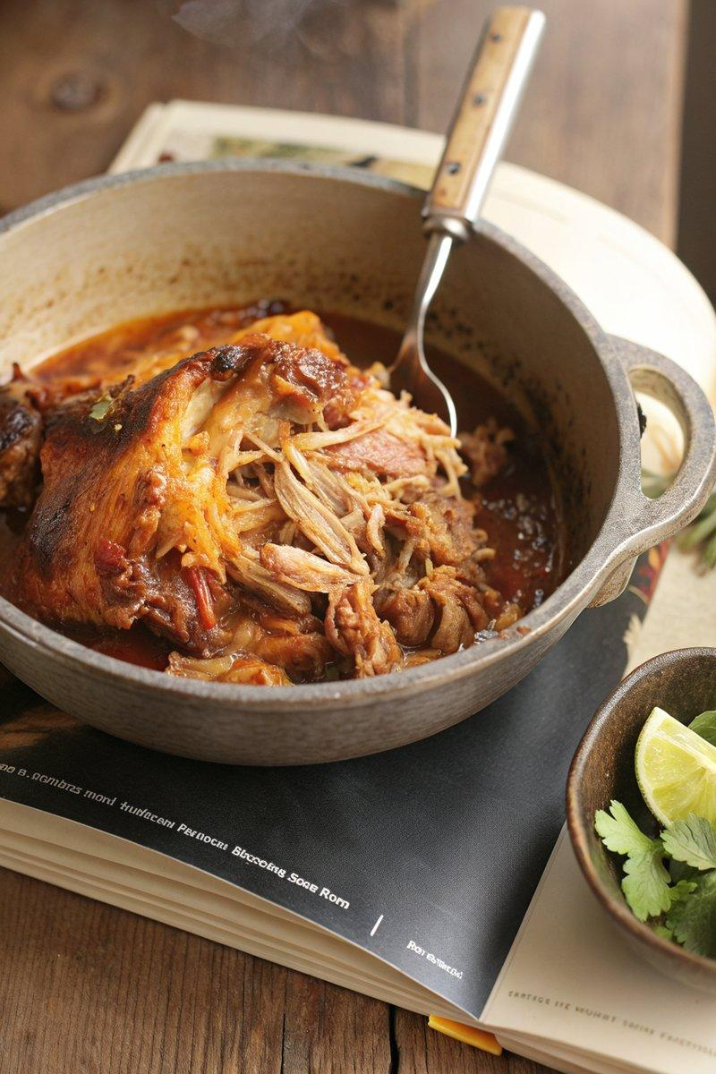

INGREDIENTS  - {'group': 'Main', 'item': '2-2.25kg boneless pork shoulder or Boston butt'}  - {'group': 'Marinade', 'item': '2 shallots'}  - {'group': 'Marinade', 'item': '2 heads garlic, peeled'}  - {'group': 'Marinade', 'item': 'Zest of 2 oranges'}  - {'group': 'Marinade', 'item': 'Zest of 3 limes'}  - {'group': 'Marinade', 'item': '2 tbsp oregano leaves'}  - {'group': 'Marinade', 'item': 'Bunch of mint leaves'}  - {'group': 'Marinade', 'item': '1 tbsp ground cumin'}  - {'group': 'Marinade', 'item': '2 serrano chiles'}  - {'group': 'Marinade', 'item': '250ml extra-virgin olive oil'}  - {'group': 'Marinade', 'item': '1 tbsp kosher salt'}  - {'group': 'Marinade', 'item': '250ml fresh lime juice or Seville orange juice'}  - {'group': 'Marinade', 'item': '250ml fresh orange juice'}  - {'group': 'Additional', 'item': 'Chicken stock, as needed'} | PREP  Blend shallots, garlic, orange zest, lime zest, oregano, mint, cumin, serrano chiles, olive oil, salt, lime juice, and orange juice until smooth. Reserve 250ml of the marinade for dipping. Place pork in a resealable bag, cover with remaining marinade, and refrigerate overnight.  COOK  Preheat oven to 200°C (400°F (200°C)). Remove pork from marinade and place in a Dutch oven, adding marinade to cover halfway. Add chicken stock if needed. Braise uncovered for 10 mins, then reduce heat to 180°C (350°F (175°C)) and cook for 3 to 3½ hrs, turning occasionally, until pork is tender and browned.  PLATING  Remove pork from the oven, let it cool slightly, then shred with forks. Toss with strained braising liquid to taste. Serve with reserved marinade for dipping, alongside rice or in tacos.

NOTES:
Ensure the pork is well-marinated for maximum flavour. Adjust seasoning with salt as needed after shredding.

