PAN-SEARED DUCK BREASTS  COOK TIME: 8 mins  SOURCE: Unknown  #duck #french #pan-fry | 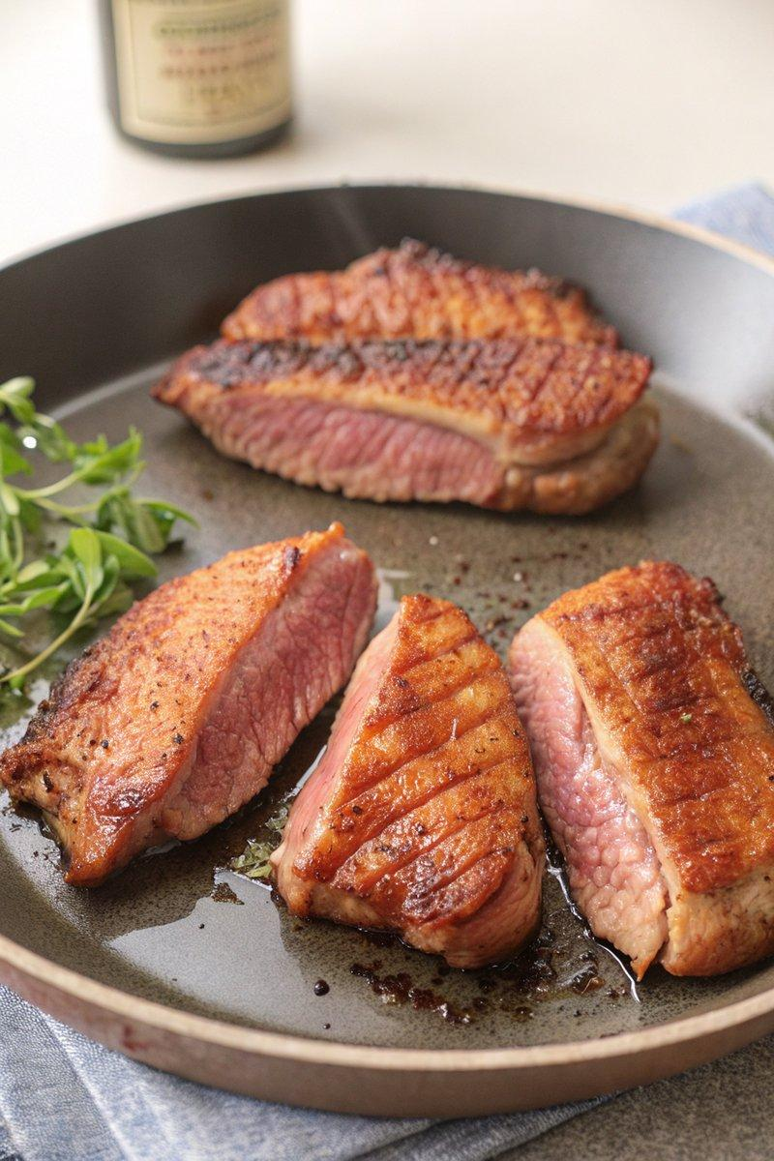

INGREDIENTS  - {'group': 'Main', 'item': '2-4 skin-on duck breasts (790g-1.6kg)'}  - {'group': 'Seasoning', 'item': 'Kosher salt, to taste'}  - {'group': 'Seasoning', 'item': 'Freshly cracked black pepper, to taste'} | PREP  Using a sharp knife, lightly score the skin of each duck breast in a crosshatch pattern, being careful not to cut into the meat. Season both sides of the duck breasts generously with kosher salt.  COOK  Place the duck breasts skin-side down in a large cold pan, ensuring at least 2.5cm (2-inch) of space between each. Cook over medium heat without moving them until the fat renders and the skin becomes golden-brown and crispy, about 5 mins. Flip the duck breasts and increase the heat to medium-high. Sear for an additional 2 to 3 mins, or until the internal temperature reaches 58°C (136°F (58°C)) for medium-rare.  PLATING  Remove the duck breasts from the pan and let them rest for 3 to 5 mins. Thinly slice the duck and season with freshly cracked black pepper before serving.

NOTES:
Save the rendered duck fat for future cooking uses, such as roasting potatoes.

