CRISPY CHICKEN FRIED STEAK WITH CREAM GRAVY  COOK TIME: 25-40 mins  SOURCE: Unknown  #beef #American #pan-fry | 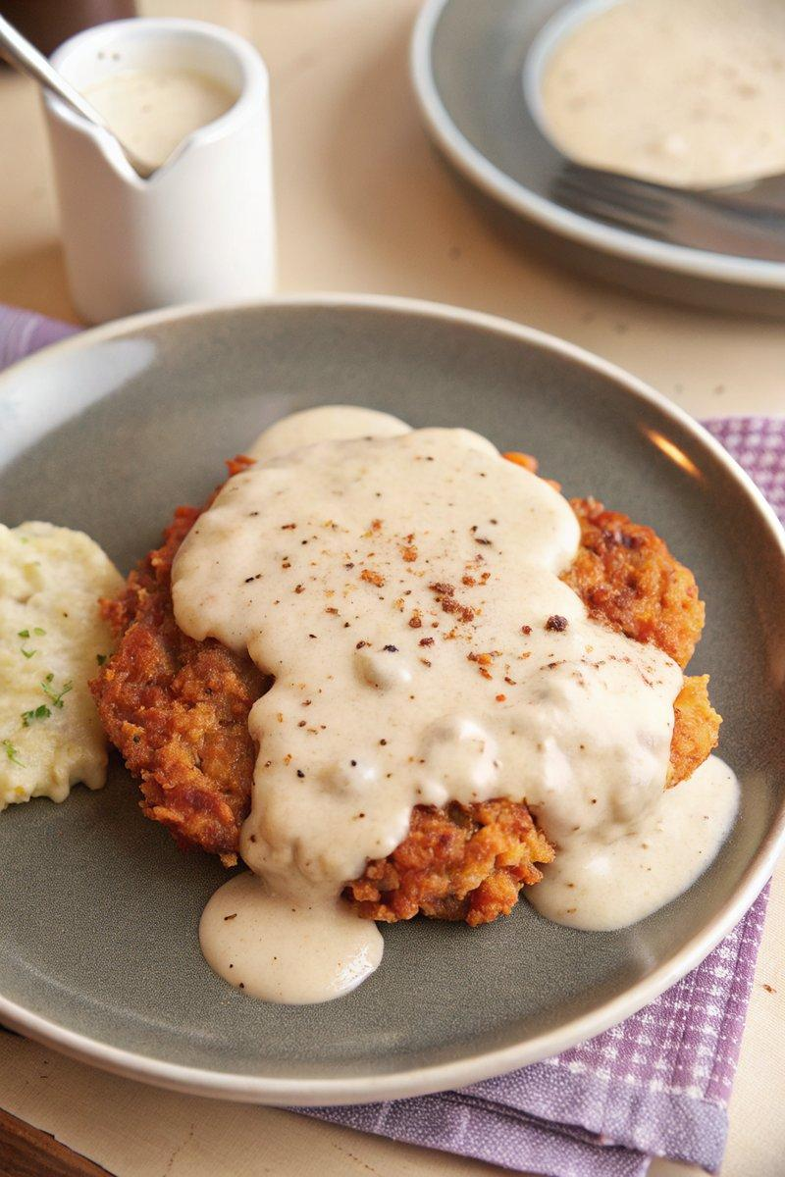

INGREDIENTS  - {'group': 'Main', 'item': '4 cube steaks'}  - {'group': 'Marinade', 'item': '500ml whole milk'}  - {'group': 'Coating', 'item': '200g coarsely crushed crackers'}  - {'group': 'Coating', 'item': '100g all-purpose flour'}  - {'group': 'Seasoning', 'item': 'Salt and freshly ground black pepper'}  - {'group': 'Gravy', 'item': '125g unsalted butter'}  - {'group': 'Gravy', 'item': '100g all-purpose flour'}  - {'group': 'Gravy', 'item': '500ml whole milk'} | PREP  Place cube steaks in a baking dish and cover with milk. Marinate at room temperature for 15-20 mins or refrigerate overnight. Mix crushed crackers, flour, salt, and pepper in a large dish.  COOK  Heat 1-inch (3cm (1-inch)) of oil in a cast-iron skillet over medium-high heat until shimmering. Remove steaks from milk, coat in cracker mixture, pressing to adhere. Fry steaks in batches for 3-5 mins per side until golden brown. Drain on a wire rack. For gravy, if oil is clean, retain 60ml in the skillet; otherwise, use butter. Add flour, whisk until browned, then gradually add milk, whisking until thickened. Season with salt and pepper.  PLATING  Serve the chicken fried steak topped with cream gravy. Garnish with freshly cracked black pepper. Pair with mashed potatoes and green beans for a complete meal.

NOTES:
Ensure the oil is hot enough before frying to achieve a crispy coating. Adjust gravy consistency with additional milk if needed.

